REQUIREMENTS ANALYSIS

Yan San Metal Pte Ltd

PREPARED BY

Business Analysis Sign Off Form
Customer | Yan San Metal Pte Ltd
Project Title/ID | YSM
Deliverable Name | SAP Business One (SBO) Requirements Document
Date/Version | 13 Aug 2025 / 1.0
Description | This template is used to collect several types of requirements into a single integrated requirement document so that all requirements are represented together in a single place, facilitating customer approval and project team understanding. The business requirements matrix, data requirements matrix, integration requirements matrix, and deployment requirements matrix are covered to this document.
Submitted for Sign-Off | AFON Project Manager / Consultant (SAP Business Unit)  Name : Simon Soh / Ricky Susanto  Signed : Ricky Susanto  Date : 13 Aug 2025
Customer Sign-Off | Yan San Metal Pte Ltd  Name : Lydia Quah (SAP B1 Project Manager)  Signed :  Date :

DOCUMENT HISTORY

Version | Date | Consultant | Comments
1.0 | 13-Aug-2025 | Ricky Susanto | Initial Document
1.1 | 27-Aug-2025 | Ricky Susanto | Update following BA Review with users
1.2 | 16-Sep-2025 | Ricky Susanto | Update following BA Review with users
1.3 | 18-Sep-2025 | Ricky Susanto | Update following BA Review with users
1.4 | 22-Sep-2025 | Ricky Susanto | Update following BA Review with users
1.5 | 22-Sep-2025 | Ricky Susanto | Update following BA Review with users

TABLE OF CONTENTS

1 ADMINISTRATION 7
1.1 COMPANIES TO IMPLEMENT 7
1.2 MODULES TO BE IMPLEMENTED 7
1.3 COMPANY DETAILS 7
1.4 DECIMAL PLACES 7
1.5 DATE FORMAT 8
1.6 TIME FORMAT (Confirmed) 8
1.7 DOCUMENT NUMBERING 8
1.8 USER MASTER DATA 8
1.9 USER AUTHORIZATION 9
1.10 DOCUMENT SETTINGS 9
1.11 ADDON CUSTOMIZATION 9
1.12 SBO MAILER 9
2 FINANCE 10
2.1 FINANCIAL CALENDAR 10
2.2 CURRENCIES 10
2.3 EXCHANGE RATES 10
2.4 CHART OF ACCOUNTS 11
2.5 DIMENSION AND COST CENTERS 11
2.6 TAX CODES 11
2.7 PROJECTS 12
2.8 EXCHANGE RATE DIFFERENCES / REVALUATION 12
2.9 FINANCIAL REPORTS 13
2.9.1 FINANCIAL REPORT TEMPLATES 13
2.9.2 BALANCE SHEET 13
2.9.3 PROFIT AND LOSS STATEMENT 14
2.9.4 TRIAL BALANCE 15
2.9.5 GENERAL LEDGER 15
2.9.6 STATEMENT OF ACCOUNTS 16
2.9.7 AGING REPORTS 17
2.9.8 GST REPORT 17
3 FIXED ASSET 18
3.1 DEPRECIATION TYPE 18
3.2 ASSET CLASS 18
3.3 ACCOUNTS DETERMINATION 18
3.4 FIXED ASSET MASTER DATA 19
3.4.1 Fixed Asset Master (Value summary): 20
3.4.2 Fixed Asset Depreciation: 20
3.4.3 Fixed asset for cost accounting: 21
3.5 FIXED ASSET ACQUISITION 21
3.6 FIXED ASSET CAPITALIZATION CREDIT MEMO 22
3.7 FIXED ASSET RETIREMENT / DISPOSAL 22
3.8 DEPRECIATION RUN 22
4 BANKING 24
4.1 HOUSE BANK AND BANK ACCOUNTS 24
4.2 EXCHANGE RATE DIFFERENCE BETWEEN INVOICE AND PAYMENT 24
4.3 EXCHANGE RATE GAIN/LOSS ACCOUNT 24
4.4 CONTRA PAYMENT 24
4.5 BANK RECONCILIATION 25
5 BUSINESS PARTNER MASTER 26
5.1 BUSINESS PARTNER MASTER DATA 26
5.1.1 BP NUMBERING SERIES 26
5.2 BUSINESS PARTNER CURRENCY 26
5.3 CREDIT LIMIT 26
5.4 CUSTOMER & VENDOR GROUPS 27
5.5 BUSINESS PARTNER PROPERTIES 27
5.6 BUSINESS PARTNER TERRITORY 27
5.7 BUSINESS PARTNER BILL-TO, SHIP-TO & PAY-TO ADDRESSES 27
5.8 SHIPPING TERMS 28
5.9 SALES EMPLOYEES 28
5.10 CONTACT PERSONS 28
6 SALES & RECEIVABLES 29
6.1 PROPOSED WORKFLOW IN SAP B1 29
6.2 SALES QUOTATION 30
6.3 SALES ORDER 30
6.3.1 GENERATING WORK ORDER FROM SALES ORDER 31
6.3.2 FORMS TO BE PRINTED FROM SALES ORDER (COMMERCIAL INVOICE & SALES ORDER) 32
6.4 PICK AND PACK MANAGER 35
6.5 PACKING LIST 35
6.6 DELIVERY 35
6.6.1 FORMS TO BE PRINTED FROM DELIVERY ORDER 36
6.7 A/R DOWN PAYMENT INVOICE 37
6.8 A/R INVOICE 38
6.9 WALK-IN CUSTOMER – PAYMENT TERM “CASH SALES” 40
6.9.1 CUSTOMER CREATION FOR CASH SALES 40
6.10 CASH-ON-DELIVERY SALES 40
6.11 RETURNS AND CREDIT NOTES 41
6.11.1 FORMS TO BE PRINTED FROM AR CREDIT NOTE 41
7 PURCHASING – A/P 43
7.1 PROPOSED WORKFLOW IN SAP B1 43
7.2 PURCHASE REQUEST 43
7.3 PURCHASE ORDER 43
7.3.1 PURCHASE ORDER FORMS PRINT OUT 43
7.4 GOODS RECEIPT PURCHASE ORDER 45
7.5 A/P INVOICE (SUPPLIER INVOICE) 45
7.6 A/P DOWN PAYMENT INVOICE 45
7.7 FREIGHT COST AND LANDED COST 46
7.8 PURCHASE RETURNS AND CREDIT NOTES (RMA) 46
8 INVENTORY 47
8.1 ITEM VALUATION METHOD 47
8.2 WAREHOUSE 47
8.3 BIN LOCATION 47
8.4 ITEM DIMENSION 48
8.5 ITEM MASTER DATA 48
8.6 BATCH MANAGEMENT (ONLY FOR COIL ITEM) 49
8.7 UNIT OF MEASURES 50
8.8 BP CATALOG NUMBERS (CUSTOMER PART NO) 50
8.9 LEAD TIME 51
8.10 MINIMUM ORDER QUANTITY (MOQ) 51
8.11 MINIMUM AND MAXIMUM INVENTORY LEVEL 52
8.12 PRICE LISTS 52
8.12.1 STANDARD PRICE LIST 52
8.12.2 DISCOUNT GROUPS 52
8.12.3 SPECIAL PRICES FOR BUSINESS PARTNERS 52
8.13 INVENTORY REVALUATION 53
8.14 INVENTORY TRANSFER REQUEST 53
8.15 INVENTORY TRANSFER 53
8.16 GOODS RECEIPT AND GOODS ISSUE 53
8.17 INVENTORY COUNTING 54
8.18 REPORTS 54
9 PRODUCTION 56
9.1 PROPOSED WORKFLOW IN SAP B1 56
9.2 RESOURCES MASTER DATA 56
9.3 PRODUCTION ROUTING 57
9.4 BILL OF MATERIALS 57
9.5 PRODUCTION ORDER 58
9.6 WORK ORDER PRINTOUT 59
9.7 PRODUCTION ISSUE 60
9.8 PRODUCTION RECEIPT 61
9.9 OFF-CUT & RETURN COMPONENT 62
10 MRP 63
10.1 FORECAST 63
10.2 MRP 63
10.2.1 ORDER RECOMMENDATION 63
11 HUMAN RESOURCES 64
11.1 EMPLOYEE MASTER DATA 64
12 APPENDIX 64
12.1 WORK ORDER QUEUE 64
12.2 SAP WAREHOUSE BIN LOCATION 64

ADMINISTRATION

COMPANIES TO IMPLEMENT
SAP B1 will be implemented to the following company:

Company Name | Live DB | Legacy System
Yan San Metal Pte Ltd

MODULES TO BE IMPLEMENTED
# | Module
1 | Financials
2 | CRM
3 | Sales
4 | Purchase
5 | Business Partner
6 | Banking
7 | Inventory
8 | Production
9 | MRP

COMPANY DETAILS
Yan San Metals Pte Ltd
Address Line 1 | 17 Tuas Avenue 4, Singapore, 639368
Address Line 2
Address Line 3
Address Line 4
Address Line 5
Telephone | (65)- 6863 2522
Fax | (65)- 6863 2522
E-Mail | sales@yansanmetals.com
Website | www.yansanmetals.com
Co. Reg. No. | 199200367G
GST Reg. No. | 199200367G

DECIMAL PLACES
The following decimal places settings will be used in SAP B1:

Type | Decimal Places (max. 6)
Exchange Rates | 6
Amount | 2
Unit Price | 6
Quantity | 5
Percent | 2
Unit | 2

After entries are made, user will not be allowed to decrease the decimal places.

DATE FORMAT
System date format will be DD.MM.YYYY. It applies to all forms and reports.

TIME FORMAT (Confirmed)
Time Format will be set to 24H, e.g. 13:00.

DOCUMENT NUMBERING
It is discussed that to allocate 99999 numbers where the first document numbering starts from 10001 across all documents.

User DO NOT need to create the new document numbering series before each new fiscal year starts.

For cash sales, user can select “Cash” numbering series during AR Invoice Creation.
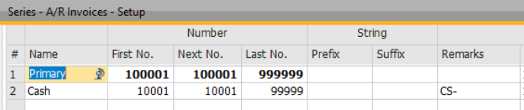

USER MASTER DATA
Every user login to SAP B1 needs to be registered in the User Master Data.

Following users are to be created in SAP B1.
S/N | Username (Max Characters 15) | Professional/ limited | Modules in Scope
1 | Mgmt88 | Professional | (ALL 3 Modules)
2 | YSMSales88 | Professional | CRM & Logistics (Restriction on Finance)
3 | YSMSales01 | Limited | CRM & Logistics Module
4 | YSMSales02 | Limited | Logistics Module
5 | YSMSales03 | Limited | Logistics Module
6 | YSMSales04 | Limited | Logistics Module
7 | YSMSubsales01 | Limited | Logistics Module
8 | YSMSubsales02 | Limited | CRM & Logistics Module
9 | YSMFin88 | Professional | ALL 3 Modules
10 | YSMFin02 | Limited | Financial Module
11 | YSMLog01 | Limited | Logistics Module

USER AUTHORIZATION
User authorization is used to control user access in the system. User who is set as super-user will have all access that cannot be overwritten.

DOCUMENT SETTINGS
Allow Future Posting Date | Yes (to be set by users in Authorization module)
Block Earlier Posting Date | Yes*
GP Calculation | Profit/Sales Price

ADDON CUSTOMIZATION
Following SDKs have been identified:

No. | SDK | Quoted | Phase | Remarks
1 | Work Order Queue | Yes | 1

Refer to appendix section for the detail requirements.

SBO MAILER
For the use of the alert that involved to send alert via email, there will the setup need to be done for the SBO Mailer.

These are the settings required by SBO Mailer.

SMTP Server | smtp.office365.com
SMTP Port | 587 (SSL)
Encoding | English (United States)
SMTP Client | Microsoft. NET
Authentication | Login Authentication
Authentication | yansan@yansanmetals.com

FINANCE

FINANCIAL CALENDAR
The financial calendar for Yan San is from April to March every year. Twelve posting periods will be created for each financial year, example as below:
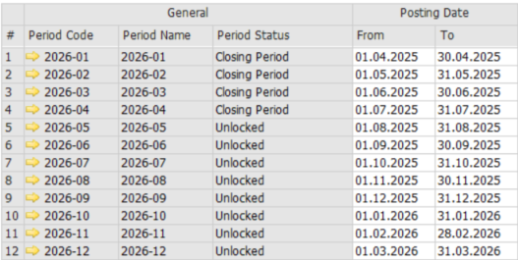

CURRENCIES
The 3-Character International Currency Codes will be adopted as the Currency Code in the system. The following Base, System and Foreign currencies are identified:
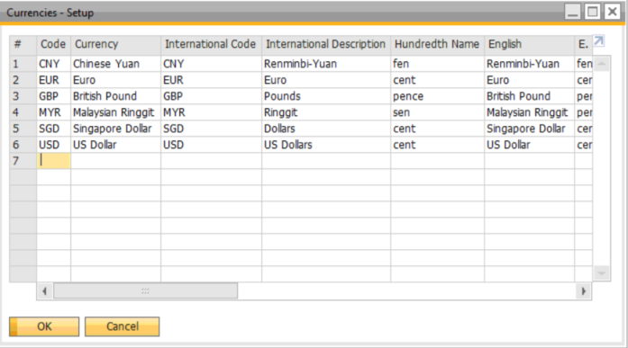

EXCHANGE RATES

For Yan San, monthly exchange rates will be maintained in the system. 6 decimal places will be setup for exchange rates.

The Exchange Rate Posting will be set to indirect method as the exchange rate will be entered according to the foreign currency, i.e. how much local currency is one foreign currency worth. For example: 1USD = 1.3 SGD

The exchange rate table in the system only allows the definition of one exchange rate per currency at any one time for a single date. The exchange rate can be overwritten at transaction level, if necessary.

CHART OF ACCOUNTS
Following are Yan San’s Chart of Accounts to be used in SAP B1.
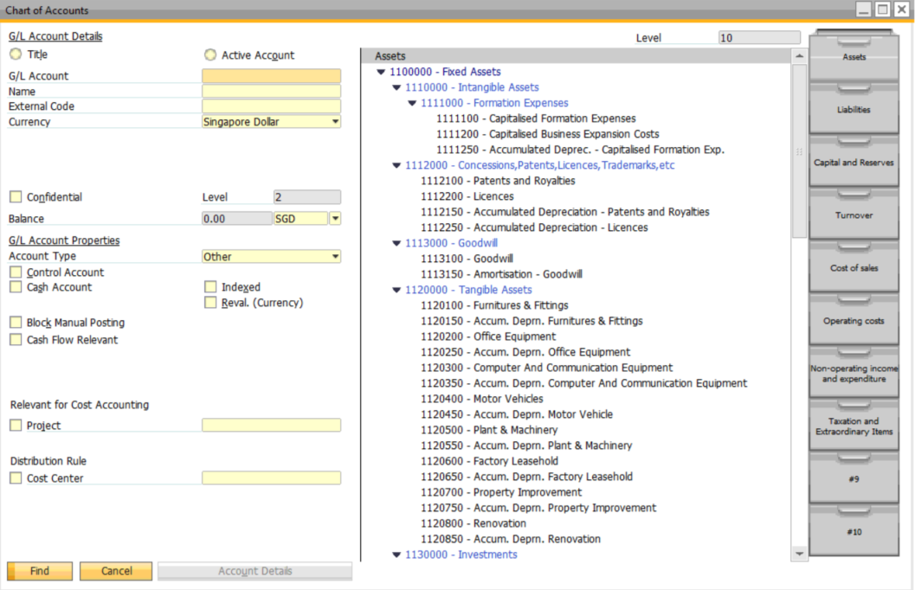

DIMENSION AND COST CENTERS
SAP B1 has cost centers feature. Profit and Loss report can be generated based on the cost centers. One dimension could have several cost centers.

Yan San has decided to use product code as cost center.

TAX CODES
The following tax codes has been created.
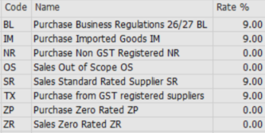

PROJECTS
User can define the individual projects that the company runs, and link each transaction created in SAP Business One to the appropriate project.

In the Projects – Setup window, specify a project code of up to 20 characters, and the full name of the project. This enables you to track the financial status of each project by using the project code as a selection criterion in various reports.

EXCHANGE RATE DIFFERENCES / REVALUATION

Month-end revaluation on foreign currency A/R, A/P and other balance sheet items balances using a month-end rate (defined after all transactions are posted) is possible in SAP B1.

The differences are charged to the Unrealized Exchange Gain/Loss accounts selected. The revaluation journal entries can be created as a Reversing Journal and can be reversed in the following month.

Before generating the month-end revaluation, finance user will override the monthly exchange rates for the last day of the month with the revaluation exchange rate for each currency. The revaluation date has to be indicated as the last date of the month to take the updated rate as the rate for revaluation.

Example:
1. The execution date to post unrealized gain/loss at 31-10-2019:
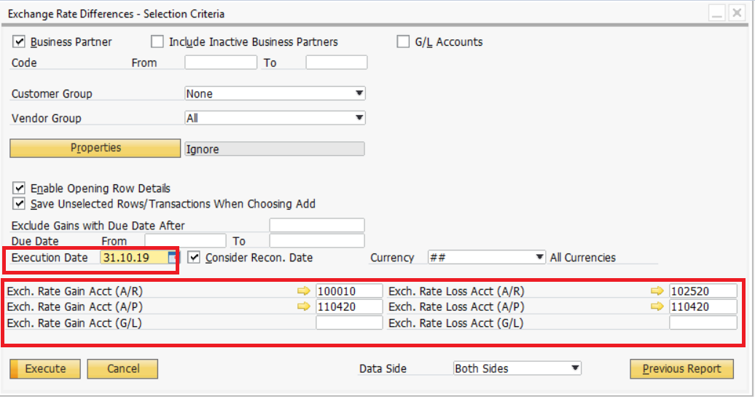

2. Ticked the ‘Auto reversal’ and date, in order for system to prompt the reversal on the stated date.
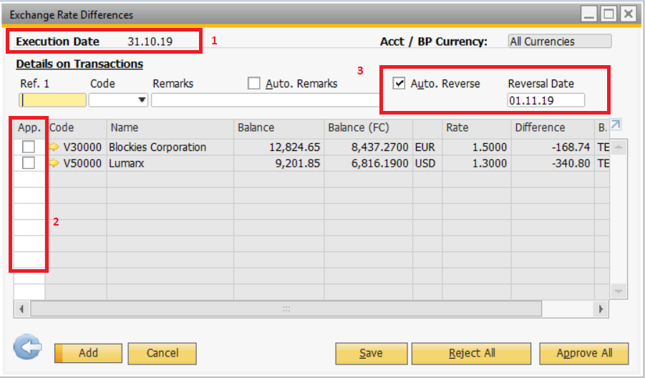

For example, if there is unreleased loss, upon the execution the JE will be at 31-10-2019:
Dr Unrealized loss/gain
Cr Customer

The entries will be reversed when the following month auto reversal is executed at 01-10-2019.

FINANCIAL REPORTS
Yan San will use the SAP B1 standard financial reports.

FINANCIAL REPORT TEMPLATES
In SAP B1, user can define financial report templates by themselves.
The template is available for these financial reports: Balance Sheet, Profit and Loss, Trial Balance, Statement of Cash Flow.

Before running those financial reports, the templates must be defined and if there is new account created in Chart of Accounts, user must add it into the template as well.

BALANCE SHEET

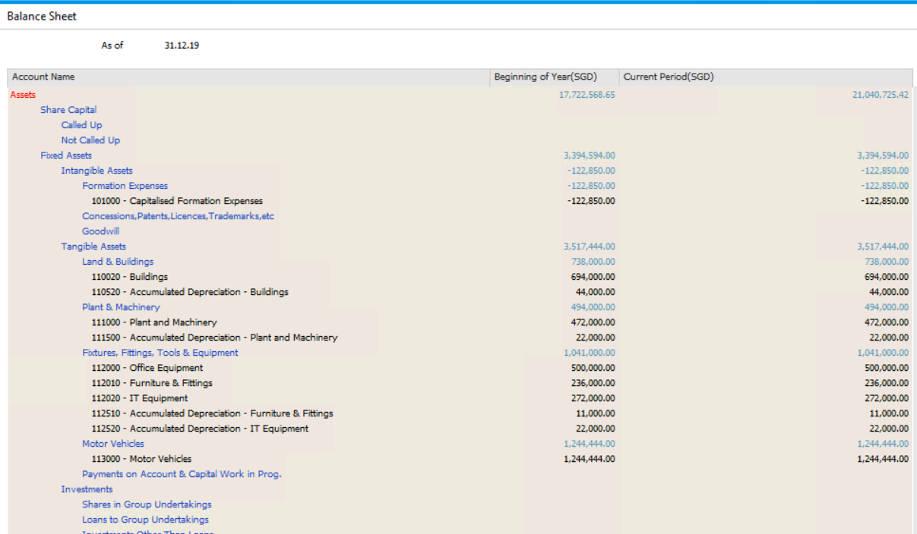

PROFIT AND LOSS STATEMENT

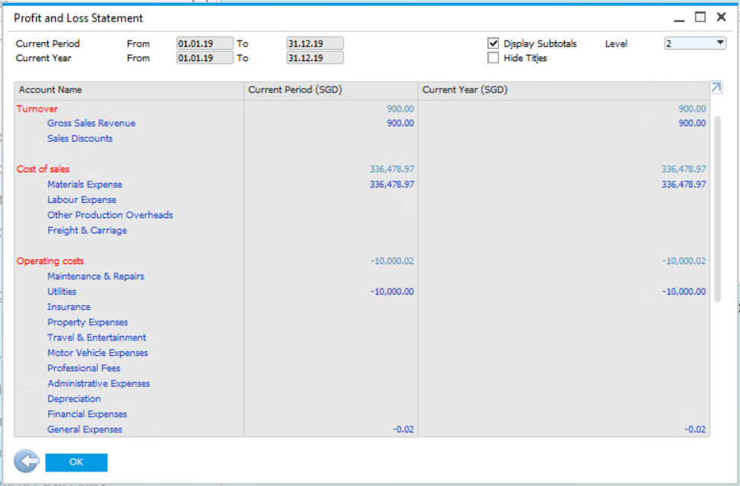

TRIAL BALANCE

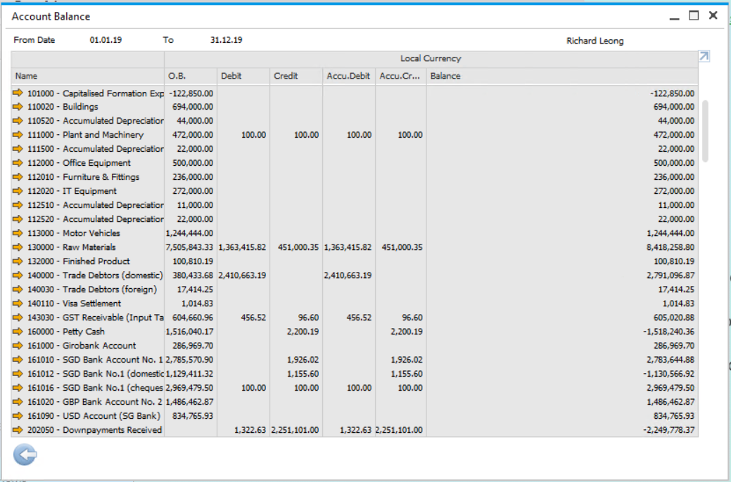

GENERAL LEDGER

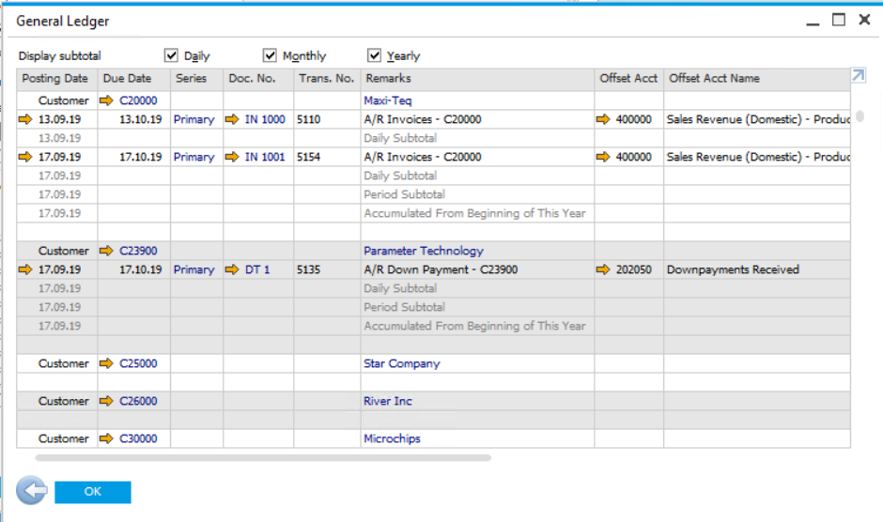

STATEMENT OF ACCOUNTS
Following Statement of account format will be customized for Yan San Metal.
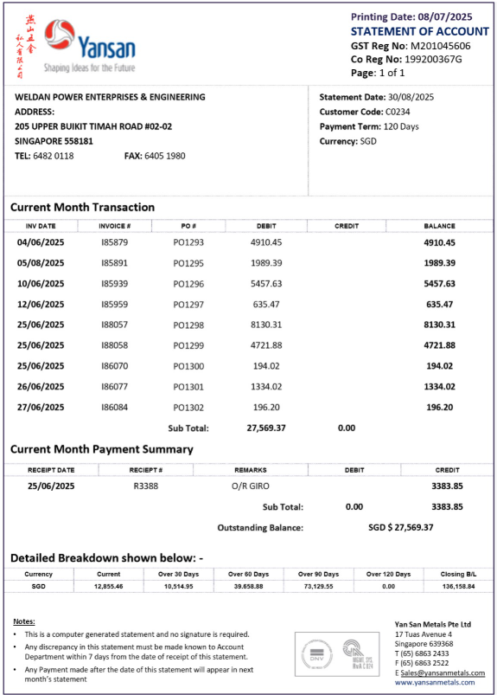

AGING REPORTS
Yan San will use standard SAP B1 Aging reports.
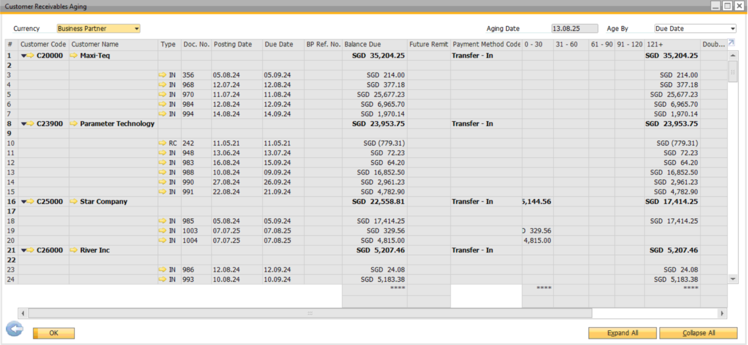

GST REPORT
Yan San will use standard SAP B1 GST reports.

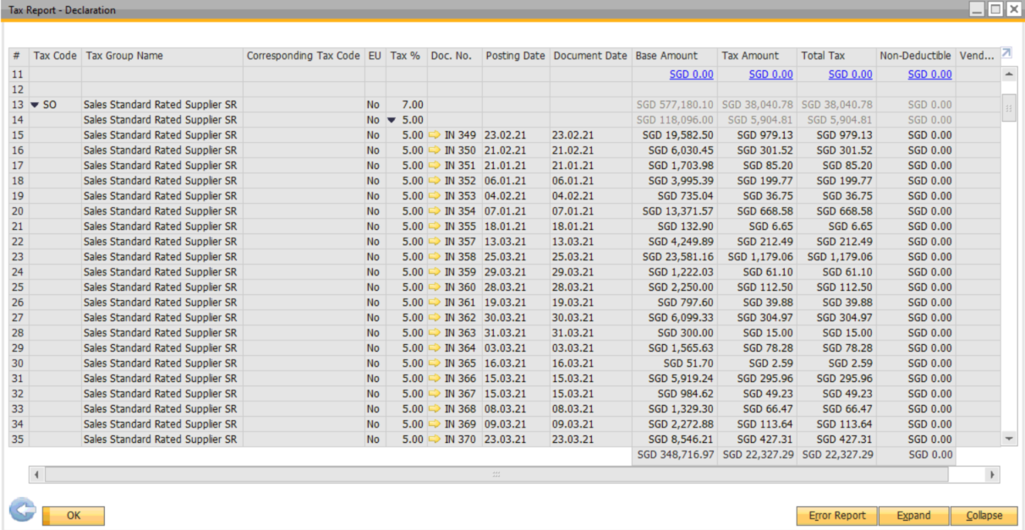

FIXED ASSET

DEPRECIATION TYPE
Yan San will use Straight line depreciation method.

Calculation Method = Acquisition Value / Total Useful Life

ASSET CLASS
Various asset classes are available for classifying fixed assets accordingly. Each asset is assigned to one asset class.

The asset classes are defined as items and appear in the item master data.

The following Asset Class will be created:
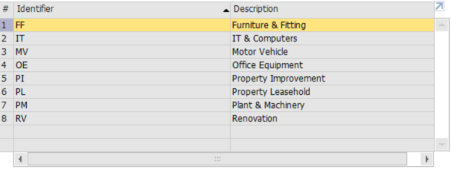

ACCOUNTS DETERMINATION
Account determination enables the system to automatically determine the relevant general ledger accounts in Financials. This means that when user creates asset transactions user does not need to manually enter general ledger accounts.

The following Account determination will be created:
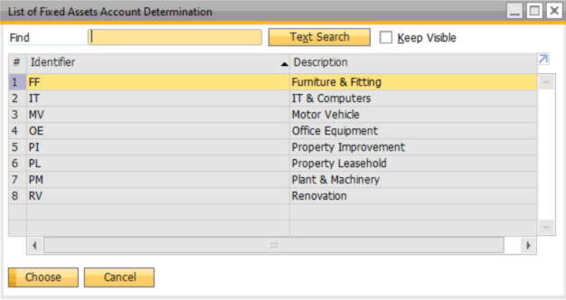
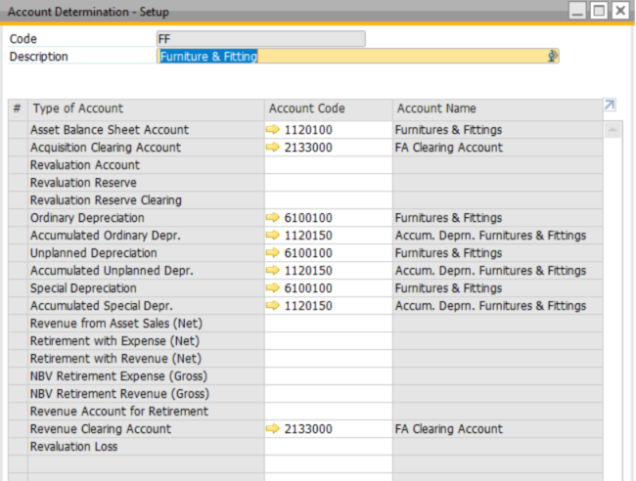

FIXED ASSET MASTER DATA
Fixed Assets allows an alphanumeric fixed asset number up to 20 characters and fixed asset description up to 100 characters.
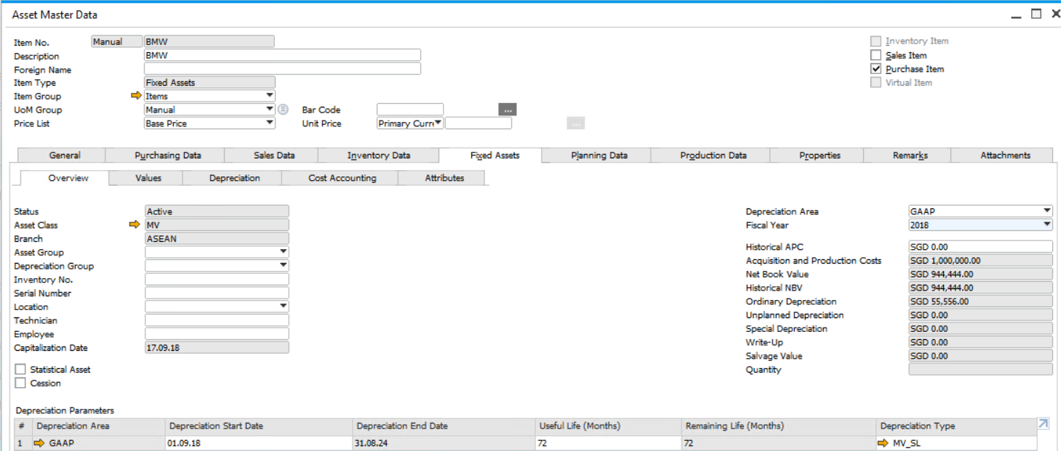

Fixed Asset Master (Value summary):
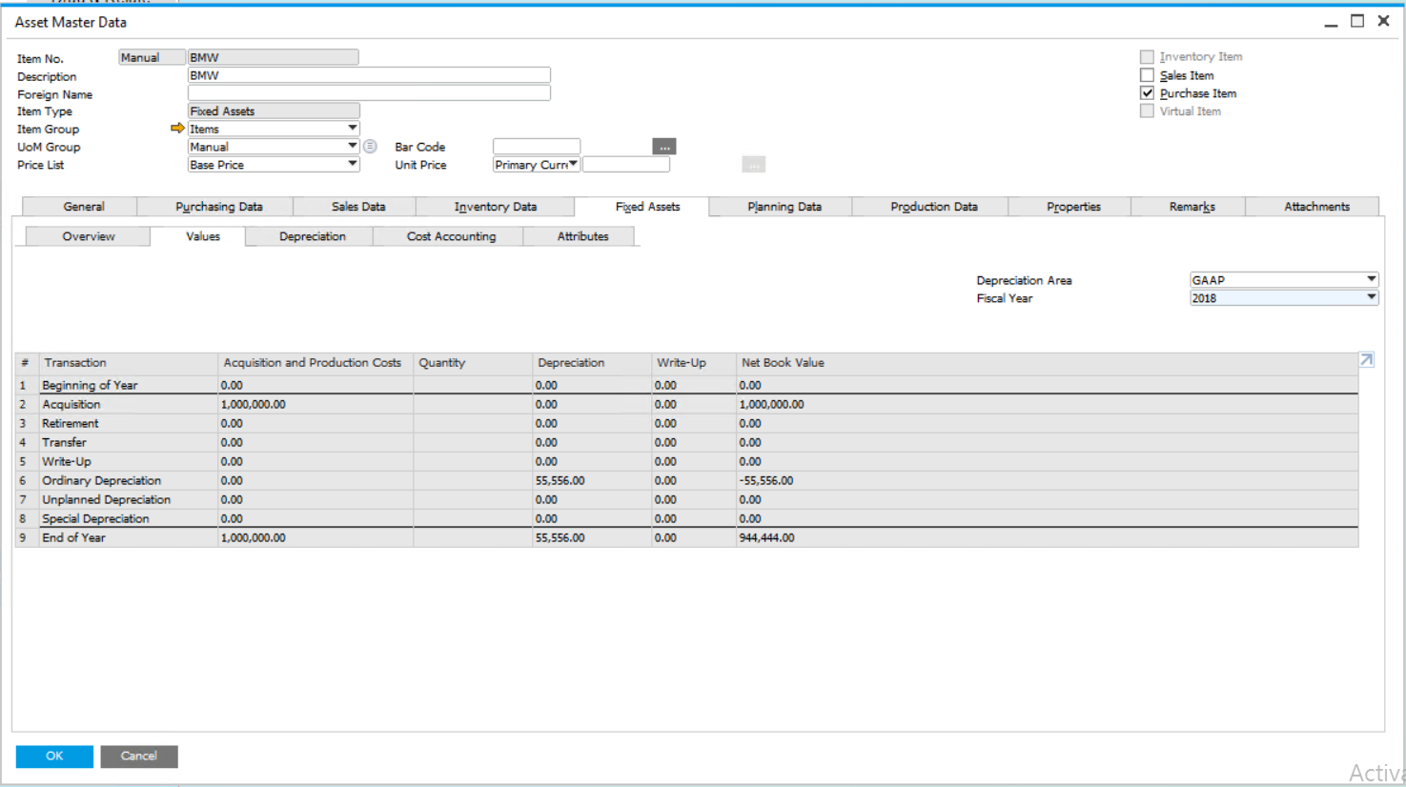

Fixed Asset Depreciation:
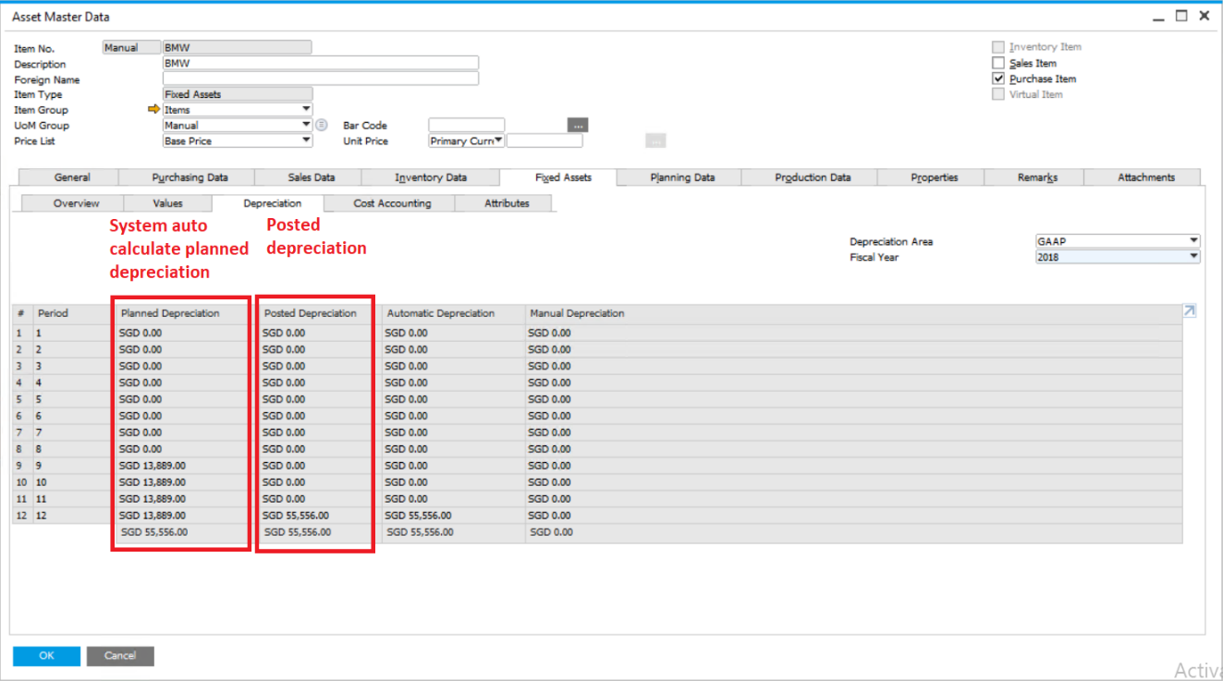

Fixed asset for cost accounting:
Fixed asset can be linked to certain distribution rules:
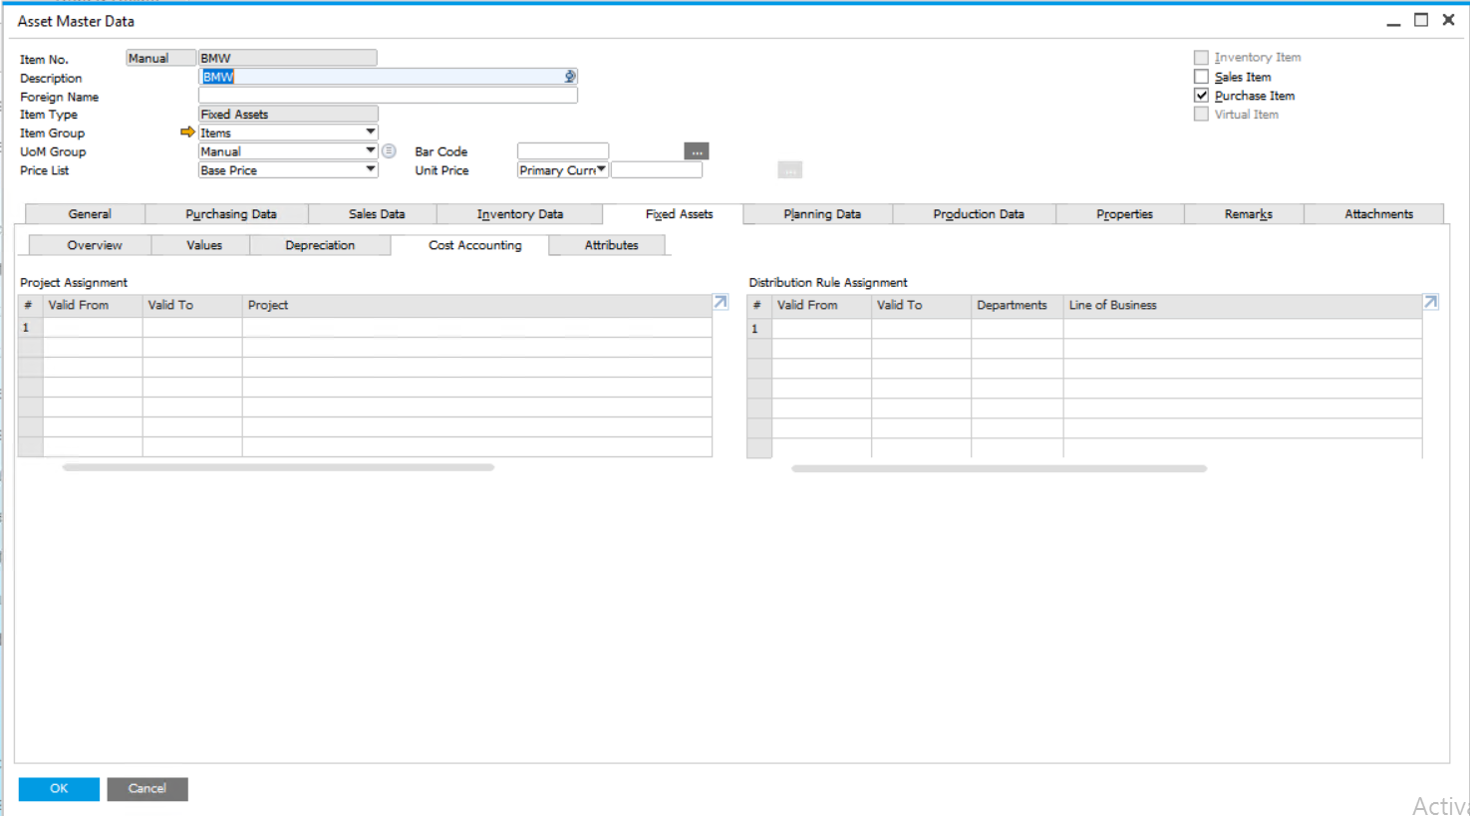

FIXED ASSET ACQUISITION
- Scenario 1 - User can use dummy item in AP invoice, then set to fa clearing account (if there will be partial retirement)

# | Process | Accounting
1 | Purchaser raises Purchase Order/Requisition, using the non-inventory item code ‘FA Clearing’
2 | Receive the item by creating Goods Receipt PO based on PO  Item Qty Price  FA Clearing 1 $10,000  ALM-P-GH3267 1 $0
3 | Raise A/P Invoice for the asset | DR Fixed Asset Clearing  DR Tax Account (if taxable)  CR Account Payables
4 | Create New Asset Master
5 | Acquisition without vendor for the asset (need to create the capitalization under Fixed Asset Module) | DR Fixed Asset Account  CR Fixed Asset Clearing
6 | If no supplier invoice recorded, and direct payment, user raise Outgoing Payment Account type | DR Fixed Asset Clearing  DR Tax Account (if taxable)  CR Bank Account

Acquisition without vendor is used because usually user wants to record down the A/P Invoice. If user creates acquisition with vendor, the A/P amount will be recorded upon the acquisition process without creating A/P Invoice document. A/P Aging will still show the amount though.

- Scenario 2 - User can use direct FA item in AP invoice, then will auto post capitalization (cannot do partial retirement)
# | Process | Accounting
1 | Purchaser raises Purchase Order/Requisition, using the Actual FA item code (Create new asset master if it is a new FA)
2 | Receive the item by creating Goods Receipt PO based on PO  Item Qty Price  ALM-P-GH3267 1 $10,000
3 | Raise A/P Invoice for the asset | There will be 2 sets of JE being generated:  DR Fixed Asset Clearing  DR Tax Account (if taxable)  CR Account Payables  DR Fixed Asset Account  CR Fixed Asset Clearing
4 | If no supplier invoice recorded, and direct payment, user raise Outgoing Payment Account type | DR Account Payable  DR Tax Account (if taxable)  CR Bank Account

FIXED ASSET CAPITALIZATION CREDIT MEMO
A capitalization credit memo, which reduces the acquisition and production costs of an asset, essentially represents the opposite of an invoice for a purchased asset.

When user create a capitalization credit memo for an asset, the credit memo always affects the asset's planned depreciation for the whole year, no matter when in the year the credit memo occurs. If the credit memo occurs in the year of the first acquisition, the asset's depreciation is decreased as of the depreciation start date. If the credit memo occurs in a subsequent fiscal year, depreciation for the asset is decreased as of the beginning of this subsequent fiscal year.

FIXED ASSET RETIREMENT / DISPOSAL
Fixed Asset retirement usually will start from A/R Invoice and followed by raise retirement without customer.

Double entry for Retirement without Customer (Not Taxable Tax Group):
DR Fixed Asset Clearing
CR Gain / Loss Disposal
DR Accumulated Depreciation
CR Fixed Asset

Assume that asset is fully depreciated; else difference goes to Gain / Loss Disposal

A/R Invoice (enter from Sales Module) for Fixed Asset sales will be using non-inventory item and default the Revenue account to Fixed Asset Clearing. Double entry as following:
DR Debtor
CR Fixed Asset Clearing
CR GST (if it is taxable)

DEPRECIATION RUN
A depreciation run can be repeated as often as necessary, provided no depreciation run has been executed for the following periods.

Double entry for Depreciation Run:
DR Depreciation
CR Accumulated Depreciation

BANKING

HOUSE BANK AND BANK ACCOUNTS

Following bank accounts will be setup in SAP B1 for Yan San Metals collections and payments:
No. | Account | GL Account | Bank Code | Bank Name | Currency
1 | 003-914-126-2 | 1252200 | DBS | DBS | SGD
2 | 0003-008-310-015-022 | 1252500 | DBS | DBS | USD
3 | 402-314-315-6 | 1252100 | UOB | UOB | SGD
4 | 402-900-313-5 | 1252400 | UOB | UOB | USD
5 | 424-811-001 | 1252300 | BBPC | BBPC | SGD

EXCHANGE RATE DIFFERENCE BETWEEN INVOICE AND PAYMENT
If there is exchange rate difference between invoice and payment, system will post the difference into realized exchange gain/loss account.

# | SAP Actions | Accounting Impact
1 | Invoice: USD 500,  Rate: 1.25 = SGD 625 | DR A/R  CR Revenue | USD 500  (USD 500) | SGD 625  (SGD 625)
2 | Payment: USD 500,  Rate: 1.20 = SGD 600 | DR Bank A/C  DR Realized Forex A/C  CR A/R | USD 500  (USD 500) | SGD 600  SGD 25  (SGD 625)

EXCHANGE RATE GAIN/LOSS ACCOUNT
Exchange Rate Gain/Loss entries may arise during document creation. Those entries will not be tagged with cost center analysis because it might involve several cost centers in a document.

User can tag a default cost center in the account master though.

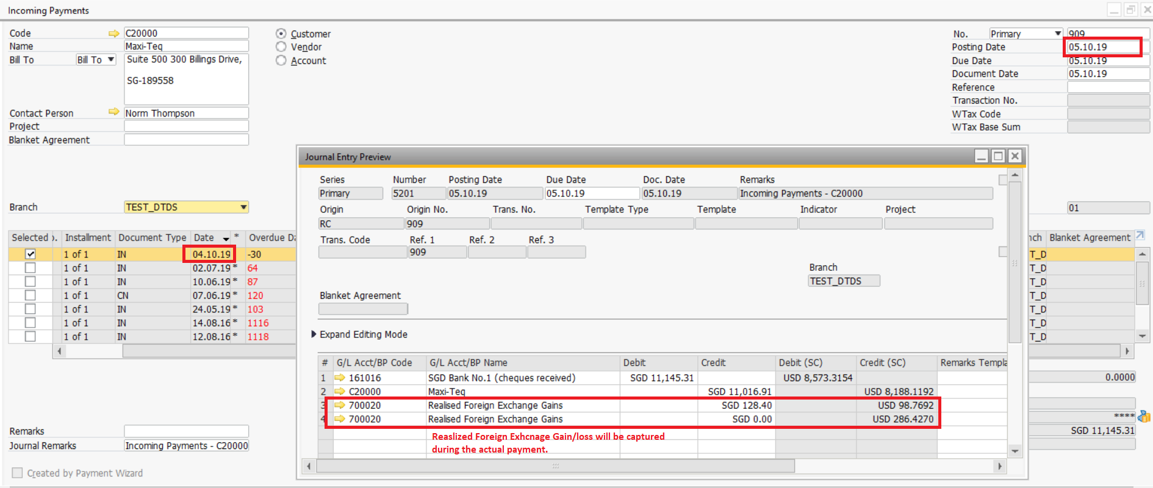

CONTRA PAYMENT
There will be cases where customer is also a supplier. Hence contra payment is practiced.

Business Partner Reconciliation can be used for contra purpose in SAP B1.

For business partners that are set as multi-currencies, all the reconciliation process will be done in Local Currency and the BP that is being reconciled must be in same currency.

BANK RECONCILIATION
User will do Bank Reconciliation in SAP B1.

For bank accounts that are set as multi-currencies, all the reconciliation process will be done in Local Currency.

SAP B1 has standard Bank Reconciliation report.

Sample of Bank Reconciliation report:

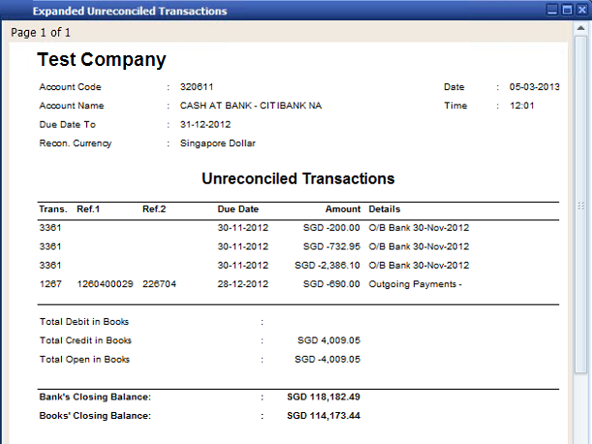

BUSINESS PARTNER MASTER

BUSINESS PARTNER MASTER DATA
All Customers, Vendors and Leads have to be created in SAP B1 before creating transactions.

In SAP B1, both customer, vendor and lead master data are maintained in one master data called the Business Partner Master Data. Therefore, the customer, vendor or lead codes could not be the same.

Type of business partner in SAP B1:
- Customer
- Vendor
- Lead (Potential customer – only convert to customer when the potential customer is secured.)
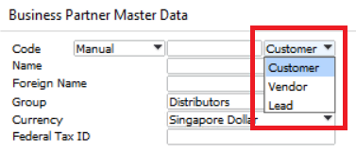

BP NUMBERING SERIES

Below is the customer coding structure for Yan San
C | 1001
For Customer | 4 digits running number
V | 1001
For Vendor | 4 digits running number

BUSINESS PARTNER CURRENCY
SAP B1 allows specific currency or all currencies option to be setup as Business Partner currency.

User has decided to use all currencies option in SAP B1. For business partners that only transact in single currency, users will set business partner currency to be specified currency.

When all currencies option is used, during the reconciliation process, it will always use Local Currency as reconciliation currency.

After a customer or vendor currency has been defined as all currencies, it is not possible to change back to be specific currency anymore.

CREDIT LIMIT
Credit Limit will be maintained for customer in system.

A warning message will be displayed to users during transactions if the credit limit is exceeded.
It is possible to disallow a user to confirm credit limit deviation using B1 user authorization.

SAP B1 allows user to put business partner on hold if necessary.

CUSTOMER & VENDOR GROUPS
Customer group can be used for reporting purpose.
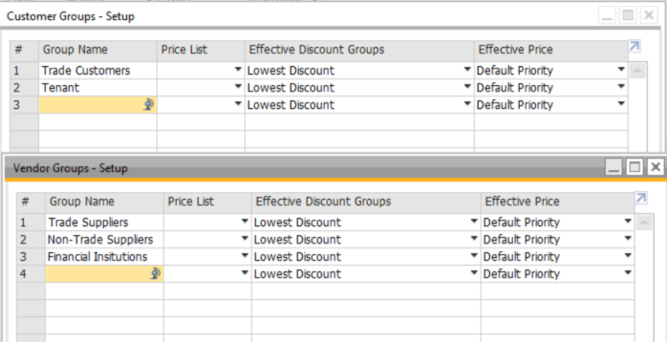

BUSINESS PARTNER PROPERTIES
BP Properties will be used to identify Related, Non-related or bank group.
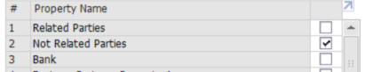

BUSINESS PARTNER TERRITORY
Business partner territory will be used to define export or local customer.

BUSINESS PARTNER BILL-TO, SHIP-TO & PAY-TO ADDRESSES
In SAP B1, one Business Partner code can have multiple Ship-To and Bill-To addresses. User will be able to select the required respective address in transaction level.

The addresses format fields in SAP B1 will be renamed and standardize as follows:

Existing | New
Street / PO Box | Address Line 1
Block | Address Line 2
Building / Floor / Room | Address Line 3
City | Address Line 4
County | Address Line 5

An address format named “General” will be created:
Line 1: Street / PO Box
Line 2: Block
Line 3: Building / Floor / Room
Line 4: City
Line 5: County

SHIPPING TERMS
Each Business Partner can define a default Shipping Terms if required.
Users can add new and or remove existing shipping terms if needed.

The following are initial shipping terms to be created:
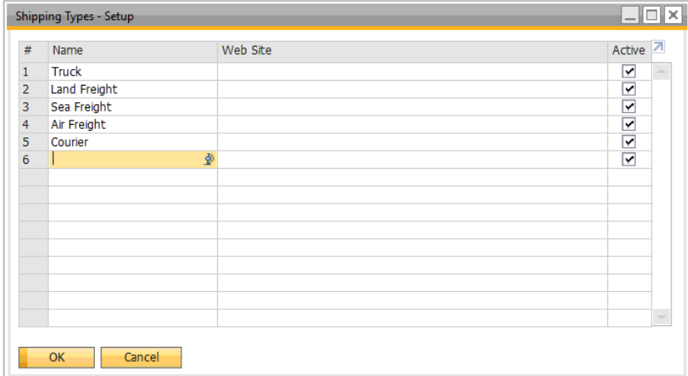

SALES EMPLOYEES
A default sales employee can be defined for every Business Partner in SAP B1. The default sales employee can be overwritten at transaction level.

CONTACT PERSONS
Multiple contact persons can be maintained for each Business Partner.
In transactions, only one contact person can be selected.
Default contact person for the business partner could be set to minimize the data entry.

SALES & RECEIVABLES

PROPOSED WORKFLOW IN SAP B1
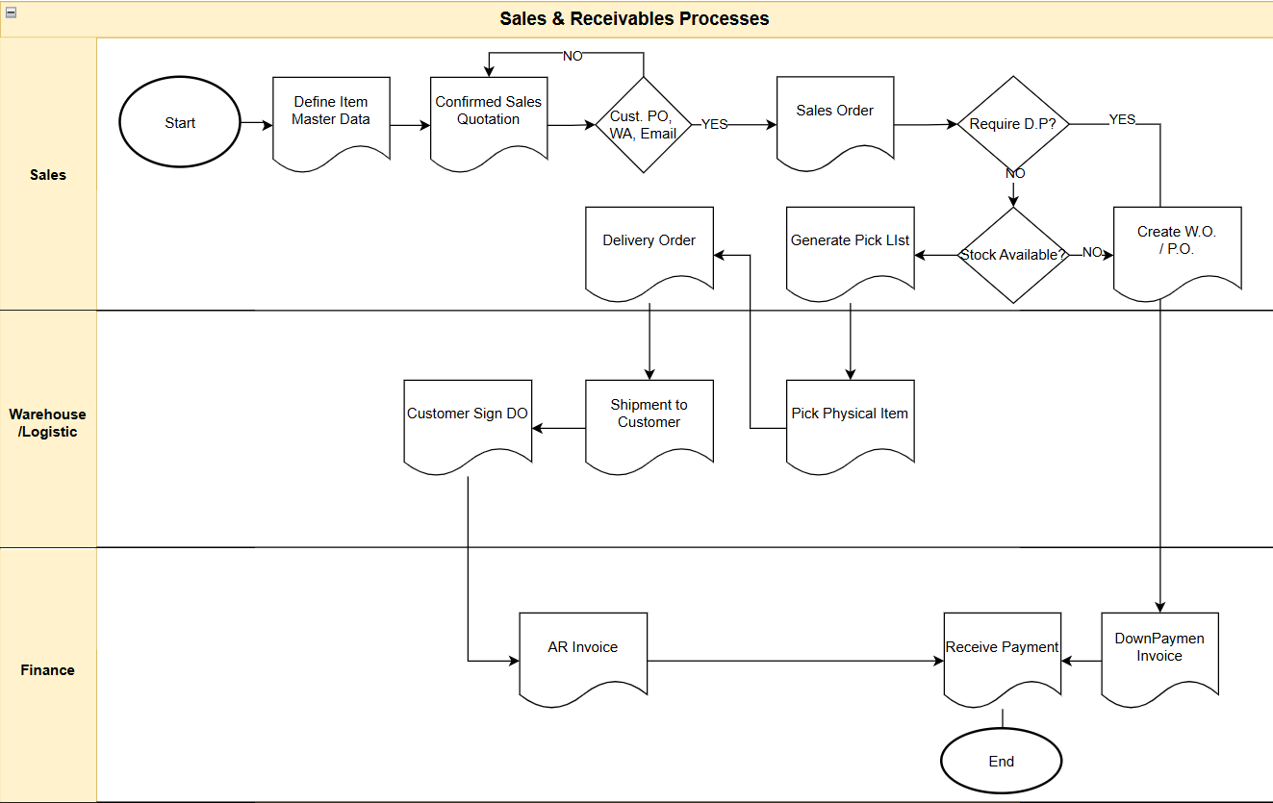

SALES QUOTATION
Initial Quotation is maintain outside SAP B1, user will only create confirmed Sales Quotation in the system.
In a case where the sales quotation is not to be converted to Sales Order, the Sales Quotation can be closed manually.
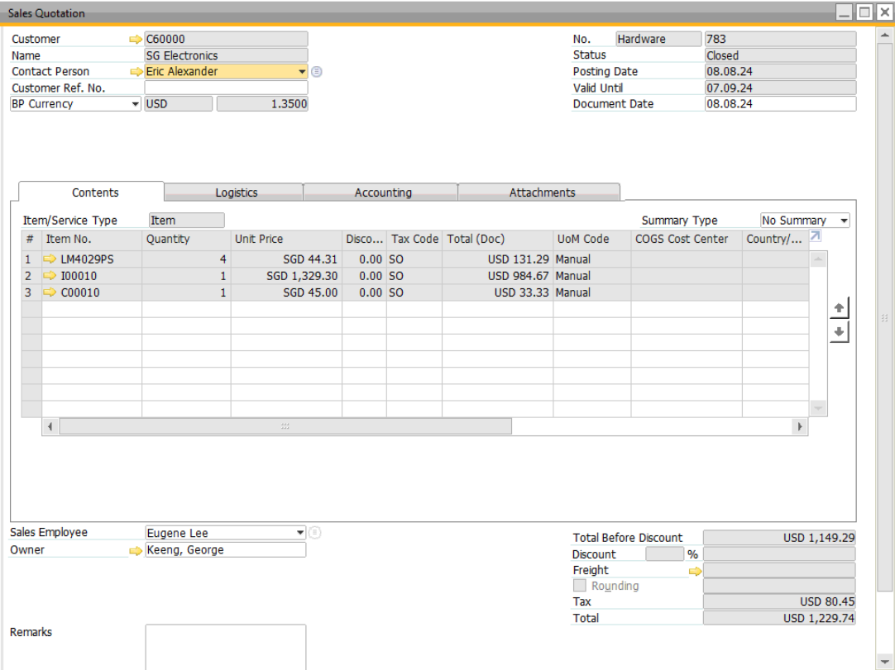

SALES ORDER
Upon Customer confirmation via PO, whatsapp, email, Sales admin will proceed to create Sales Order in SAP B1.
In Sales Order, information of customer PO number will be entered as Customer Reference Number. Sales Order has impact on inventory status for ‘Committed’ column but no accounting posting created.
** Production department will proceed with creation of Bill of Materials prior to generating Work Order.
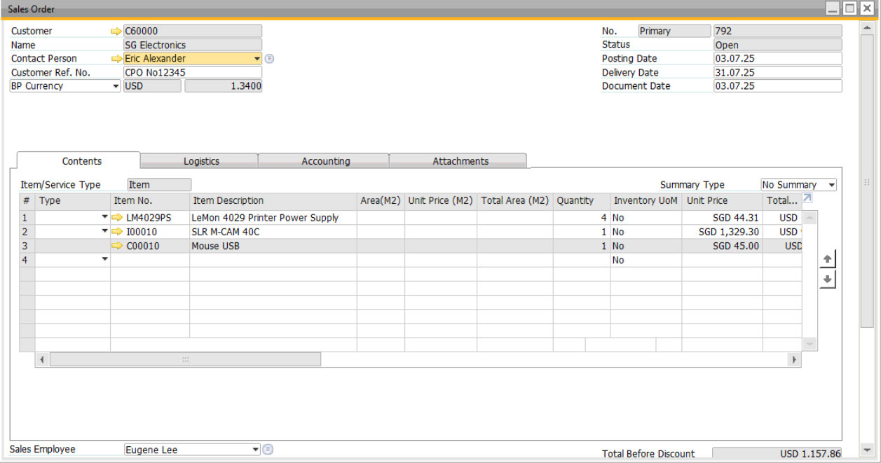

GENERATING WORK ORDER FROM SALES ORDER
As part of automation, the work order can be created from sales order (define the BOM prior to triggering this function).
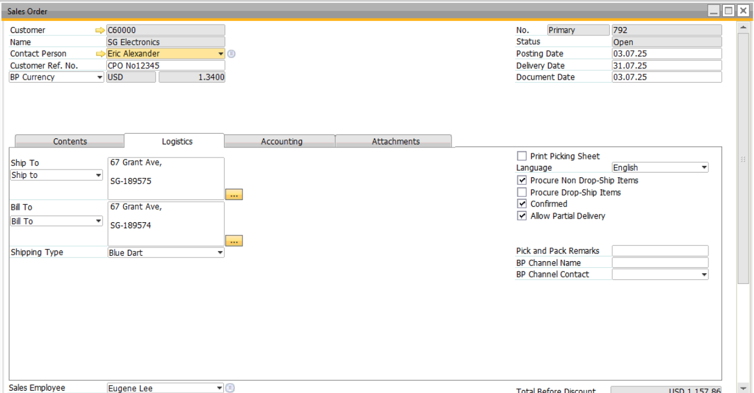

The production order will be generated as many as manufactured item included in the SO. For example, SO includes 10 manufacturing item code. There will be 10 production orders created. However, the Work Order printout will consolidate the 10 items.
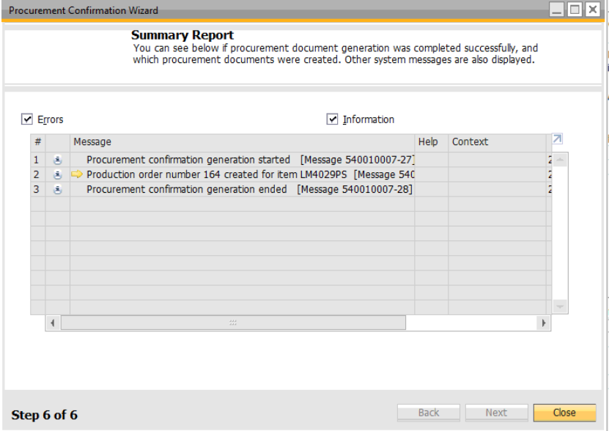

FORMS TO BE PRINTED FROM SALES ORDER (COMMERCIAL INVOICE & SALES ORDER)
The following are forms (Commercial Invoice) to be printed from the sales order document.

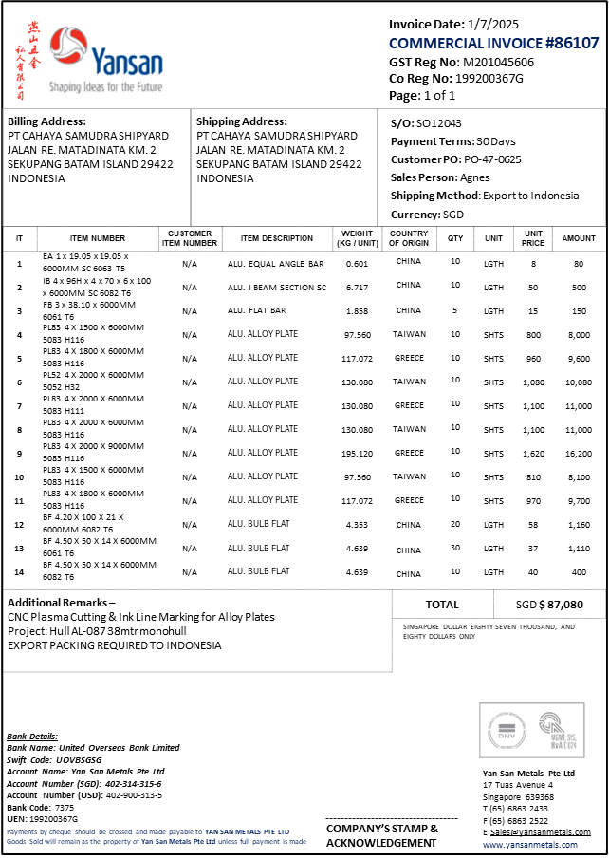

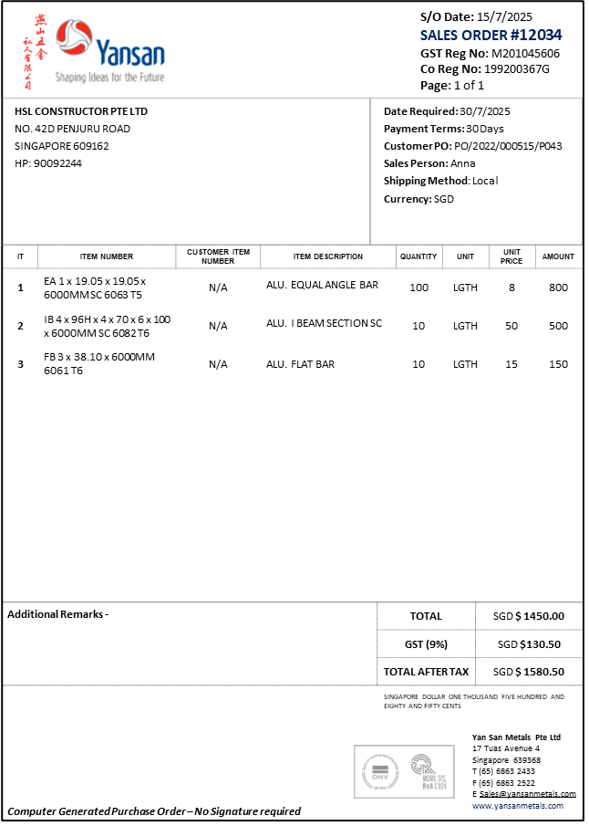
REQUIREMENTS:
- ADD IN REMARKS BY LINE ITEM

PICK AND PACK MANAGER
Pick and Pack Manager is used by the warehouse user to monitor Sales Order to be delivered to customer. In the module, user is able to view the fulfillment % of the order in terms of quantity.

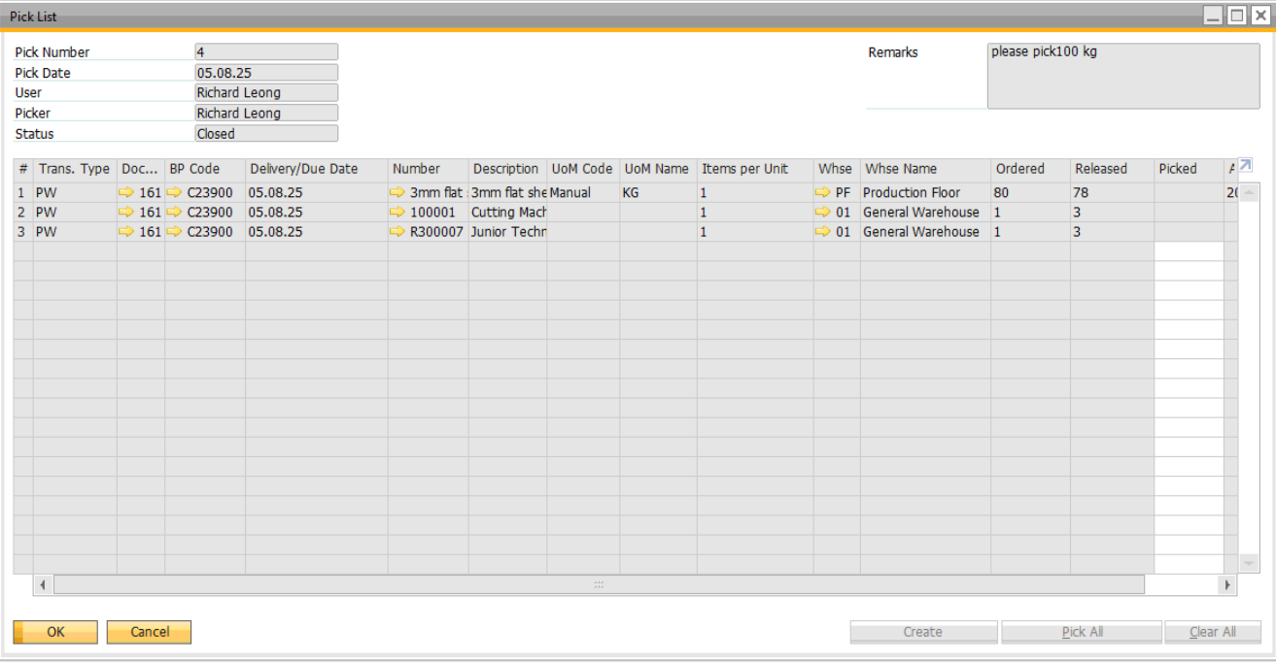
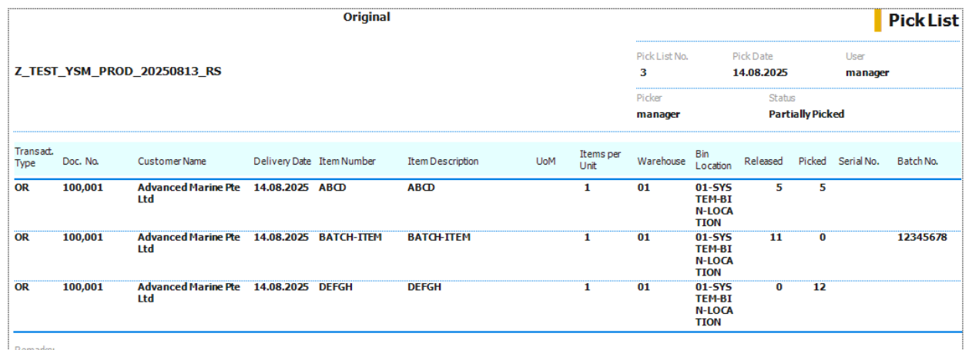

PACKING LIST
Due to too many variables, it was decided to print packing list outside SAP B1.

DELIVERY
After the goods have been prepared to be delivered, a Delivery Order will be printed out in Delivery module.

For items that are maintained by serial and batch number, there is a need to choose the relevant serial and batch number before the delivery order could be posted.
Posting Delivery Order document will reduce in-stock quantity.
The Journal Entry for this transaction will be:
DR Cost of Goods Sold
CR Inventory

FORMS TO BE PRINTED FROM DELIVERY ORDER
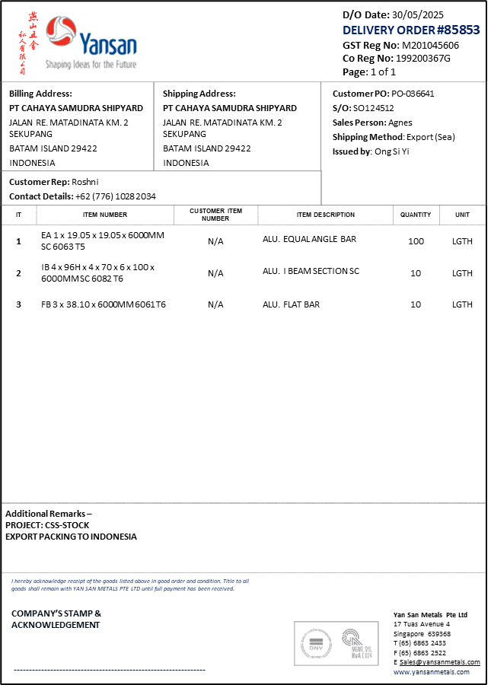

A/R DOWN PAYMENT INVOICE
A/R Down Payment Invoice will be created to request a down payment from customer. The Down Payment can be created from Sales Order document.

DR A/R
CR Down Payment Clearing Account

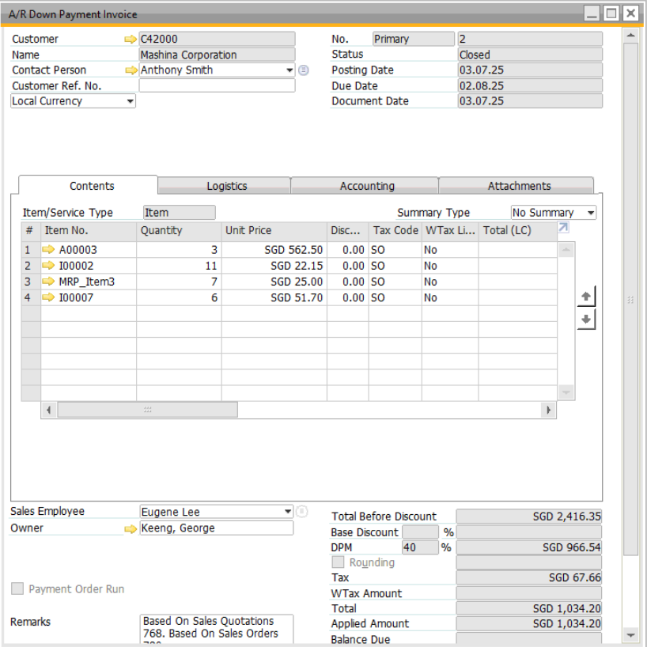

A/R INVOICE
After the delivery is sent to customer, user may issue the A/R Invoice after certain period of the delivery or at the same time.
The Journal Entry for this transaction will be:
DR A/R
CR Sales

After A/R Invoice is created, no more changes can be made to the A/R Invoice details. If an A/R Invoice is created wrongly, user needs to raise cancellation document.

A/R Invoice can also be created directly without a sales order. If an inventory item code is selected in such A/R Invoice, quantity will be reduced.

The down payment will offset the AR invoice amount when the Sales Order is linked to the downpayment document.
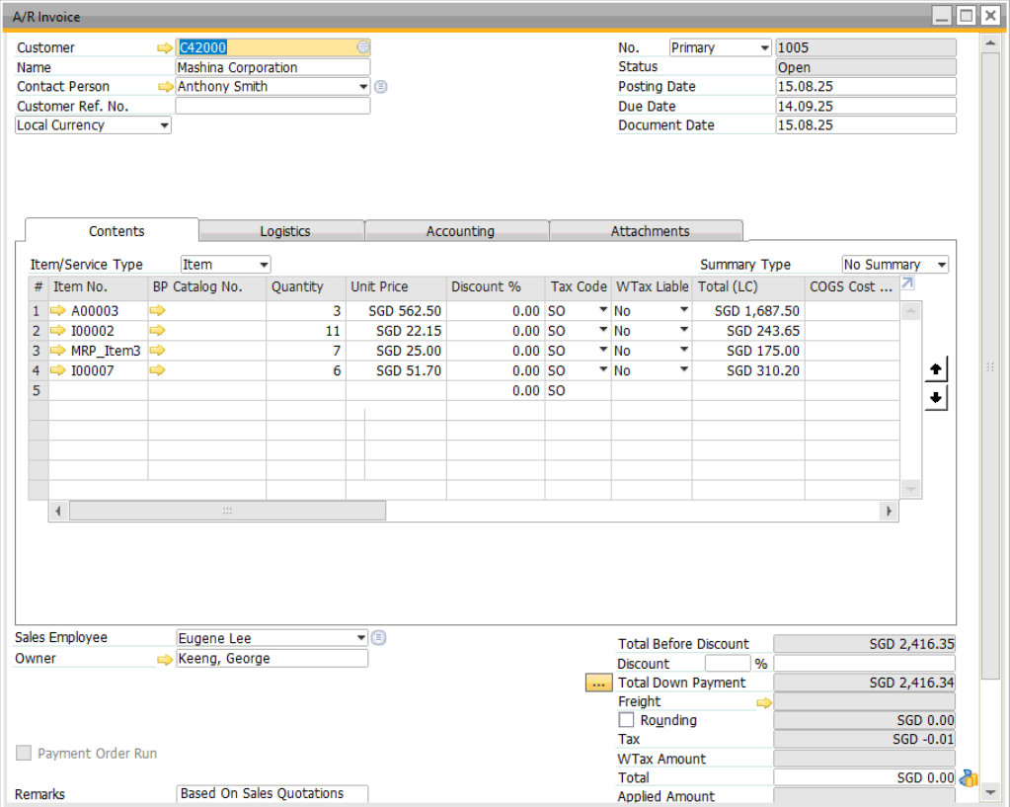
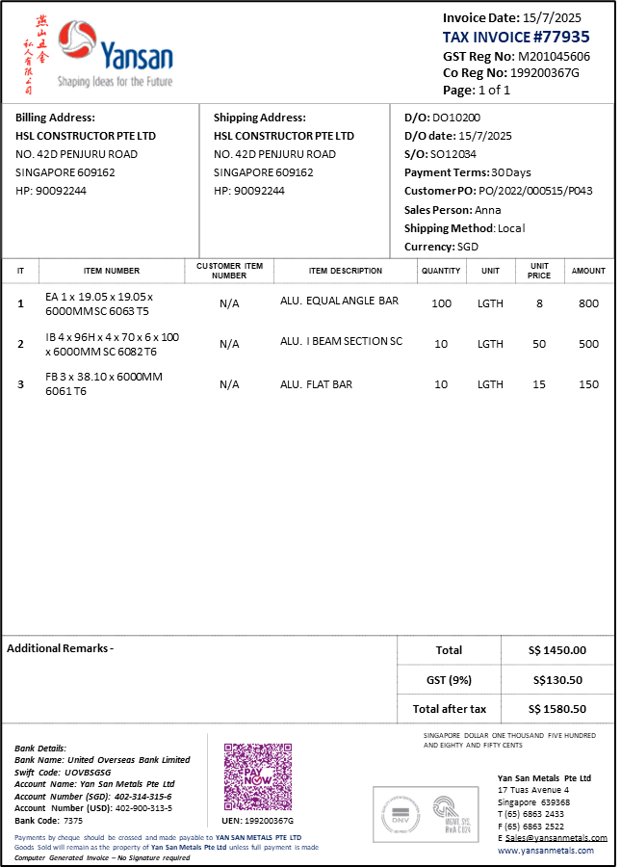

REQUIREMENTS:
- ADD IN REMARKS BY LINE ITEM

WALK-IN CUSTOMER – PAYMENT TERM “CASH SALES”
Walk-In-Customer Cash Sales is referring to customer who are purchasing YSM products and paying cash for item they are purchasing.

In SAP B1, the cash sales customer record will be recorded individually. Meaning, one cash-customer will be created as one customer master data.

The payment term of this customer will need to be set as “Cash Sales”.

The process-flow for walk-in customer cash sales as follows:
- Create New Customer Master Data (to be done by Sales Team)
- Create Sales Order
- Create pick list
- Convert pick list to AR Invoice
- Receive payment from customer

CUSTOMER CREATION FOR CASH SALES
Considering the cash sales can be done during the weekend, it was decided to allow Sales team to create Customer Master Data with payment term is “Cash Sales”.
Meaning, there will be a control where Sales team cannot create Customer Master Data other than using “cash Sales” Payment Term.

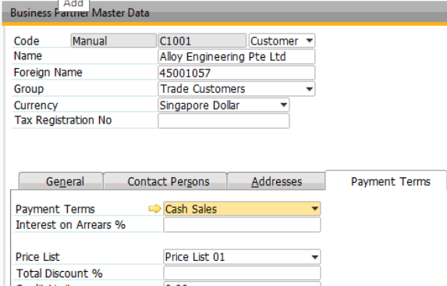

CASH-ON-DELIVERY SALES
Cash-On-Delivery is referring to a sales in which upon delivery by YSM, customer would pay for the goods.

In SAP B1, the Cash-On-Delivery customer record will be tagged as “Cash-On-Delivery” payment term.

The normal sales process is applied for Cash-On-Delivery and other payment terms (except for Walk-In-Customer Cash Sales). Refer to point 6.1 above for the detail flow.

RETURNS AND CREDIT NOTES
If there is a sales return from customer, Return or A/R Credit Memo can be used in SAP B1.

In SAP B1, if only delivery order is created, meaning not yet invoiced, return document needs to be created. A return document will increase inventory.

After A/R Invoice has been issued, A/R Credit Memo has to be raised in order to cancel / partial cancel the Invoice.

A/R Credit Memo with inventory items will affect the debtors account as well as inventory account and quantity.

A/R Credit Memo with non-inventory items or drop ship warehouse will not affect inventory.
For example: over-billing to customer.

Once the A/R Invoice has been converted to A/R Credit Memo, the A/R Invoice status becomes closed and the Sales Order status is re-opened. User can proceed with the next invoicing based on the opened Sales Order.

Return Request approval can be setup in SAP B1. Refer to the appendix for approval setup.

FORMS TO BE PRINTED FROM AR CREDIT NOTE

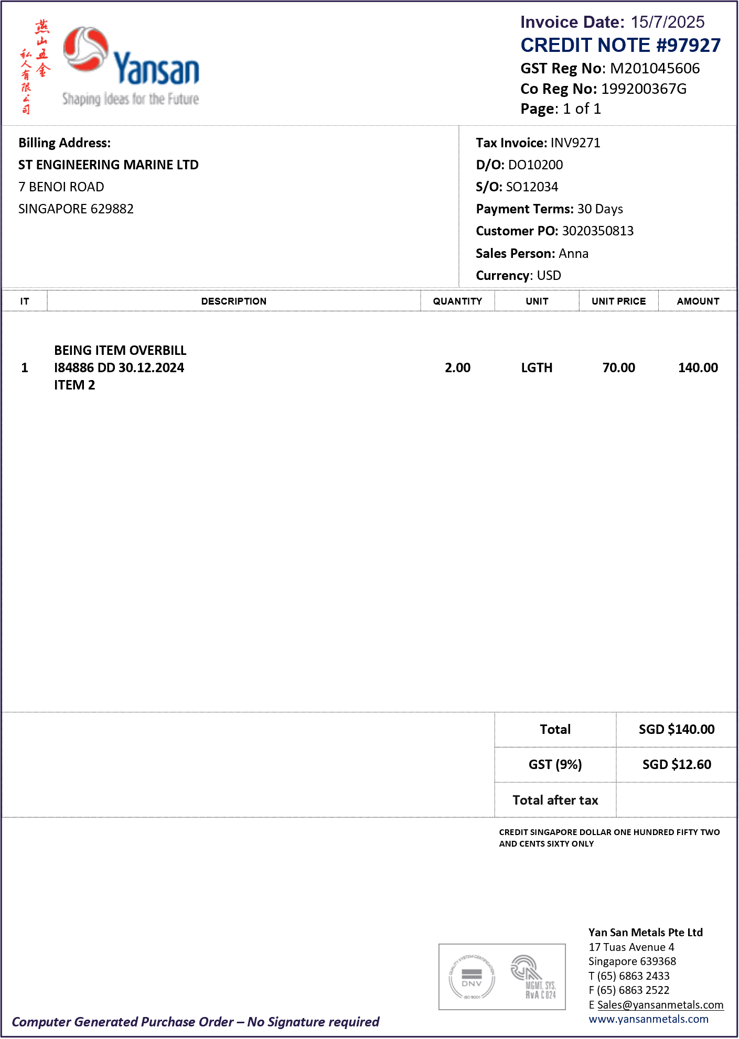

PURCHASING – A/P

PROPOSED WORKFLOW IN SAP B1

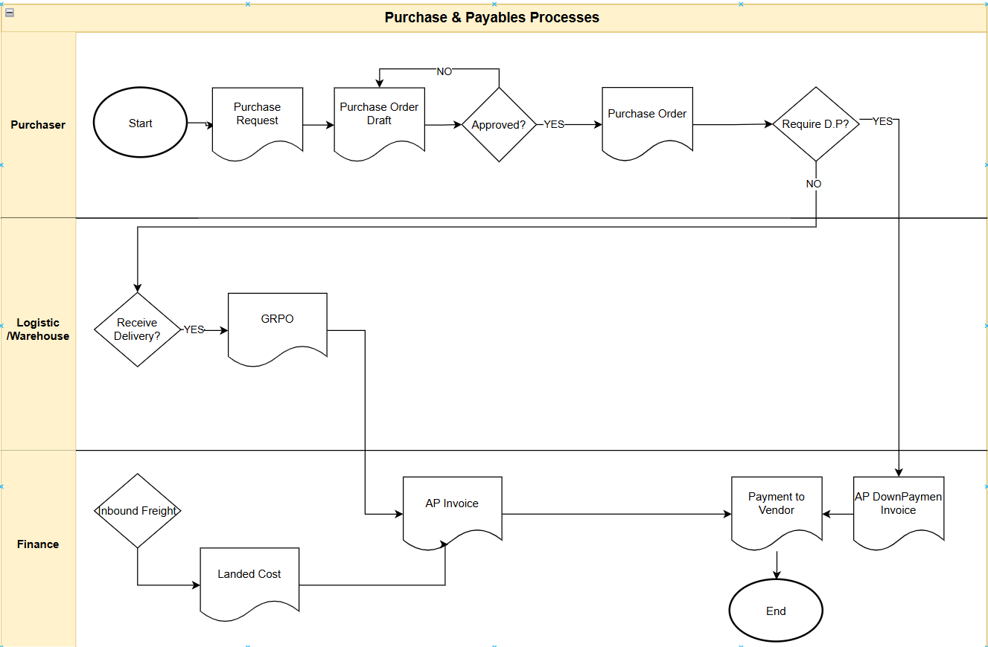

PURCHASE REQUEST
The purchase request enables users and employees in the organization to initiate a purchasing process by submitting their needs for certain goods or services. The purchase request can then be copied to purchase quotation or purchase order for further processing.

As Purchase Request is an internal document, in Yan San, the form print out is not necessary.

PURCHASE ORDER
Once the Purchase Requisition is approved, purchaser will create the Purchase Order in system.

Purchase Order has impact on inventory status for ‘Ordered’ column but no accounting posting created.

PURCHASE ORDER FORMS PRINT OUT
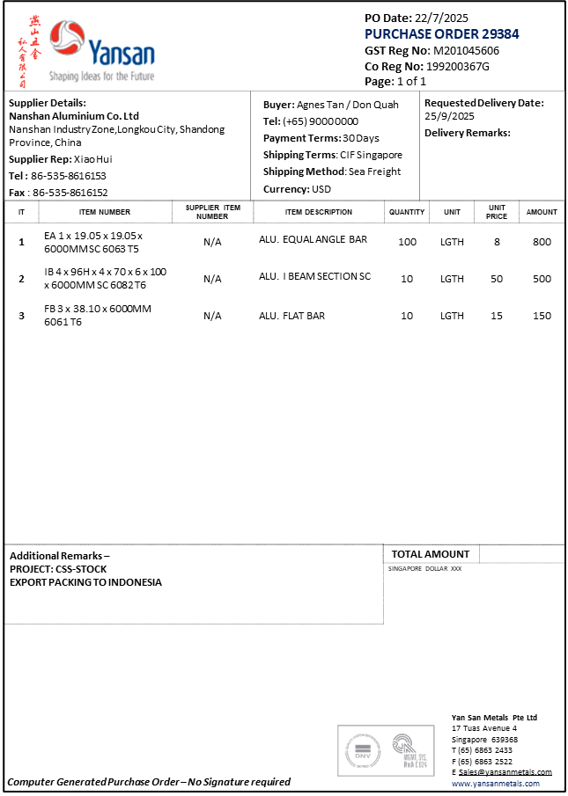

REQUIREMENTS:
- ADD IN REMARKS BY LINE ITEM

GOODS RECEIPT PURCHASE ORDER
In SAP B1, user can receive more than the PO quantity and amend the PO according to the receiving quantity before do the receipt.

After receiving the items, logistic user will enter the goods receipt PO into SAP B1.
SAP B1 allows user to create Goods Receipt PO using the copy from / to function available. The information from the Purchase Order is copied into the Goods Receipt PO.

There was a requirement to block posting GRPO when the quantity over the threshold set. i.e. 5%.

Partial receipt is possible. If the receipt quantity is less that purchase order quantity, then system will consider the purchase order as partial received and the purchase order will remains open. If there are no more receipt to be done, user can manually close the purchase order.

If the purchase order is fully received, the purchase order will be closed by the system.

A/P INVOICE (SUPPLIER INVOICE)
A/P Invoices will be created in SAP B1. A/P Invoice can be copied from open Goods Receipt PO or open Purchase Order.

For stock items, accounts will copy A/P Invoice from Goods Receipt PO.
For non-stock items, accounts will copy A/P Invoice from Purchase Order / Goods Receipt PO.

During the entry of A/P Invoice, there are three dates that user need to take note:
Posting Date : date of posting into the system
Due Date : system auto-calculate based on payment terms in PO, can be edited manually
Document Date : original supplier invoice date

In SAP B1, if the stock item price in A/P invoice is different from goods receipt PO, the difference will be adjusted to a price difference account.

A/P Invoice can also be created directly without a goods receipt PO or purchase order. If an inventory item code is selected in such A/P Invoice, quantity will be increased.

After A/P Invoice is added, no further amendments can be made to the document details.

If an A/P Invoice is created wrongly, user has to raise A/P Credit Memo.
Finance users may also create service type invoice and select the GL account to debit.

A/P DOWN PAYMENT INVOICE
When vendor sends an invoice for a down payment, user will enter it in SAP Business One as an A/P down payment invoice.

The posting created by this document is relevant only for the accounting system and does not affect inventory values. User can create this document based on a purchase order or a goods receipt PO, just as you do with your regular A/P invoices.

The journal entry for this document will be:
DR Down Payment Clearing Account
CR A/P

FREIGHT COST AND LANDED COST
Freight Cost is applied and can be entered during Purchase Order process in SAP B1.
Freight cost will be set into certain accounts and during the A/P Invoice process; the respective accounts will be debited.

There can also be cases whereby freight cost is only known when supplier invoice is received. Therefore for such cases, user will enter the freight cost only when creating A/P Invoice. This is possible in SAP B1.

Freight cost can also be charged by a separate supplier especially for import. Therefore for such cases, users will create a Landed cost document from Goods Receipt PO in SAP B1 to include the landed cost into item cost. This may be an estimated or actual landed cost.

If an estimated cost is used, it is possible to create another landed cost document from the previous landed cost document with actual freight cost and adjustment will be posted accordingly.

Finance will then create an A/P Invoice for the freight cost to affect creditor account.

PURCHASE RETURNS AND CREDIT NOTES (RMA)
If there is a purchase returns to supplier, Goods Return or A/P Credit Memo can be used in SAP B1.

In SAP B1, if only Goods Receipt PO is created, meaning not yet invoiced, PO Return needs to be created. PO Return will reduce inventory.

After A/P Invoice has been issued, A/P Credit Memo has to be raised in order to cancel / partial cancel the Invoice.

There will be a case whereby A/P Invoice has been issued and paid; the A/P Credit Memo created will be used to knock off against the next order.

For scenarios whereby returns are done after supplier invoice is received, user will create a PO return to reduce inventory, then finance user will wait for supplier credit memo before creating A/P credit memo from the return document.

A/P Credit Memo with inventory items will affect the creditors account as well as reduce inventory.

Return Request approval can be setup in SAP B1. Refer to the appendix for approval setup.

INVENTORY

ITEM VALUATION METHOD

Yan San Metal has decided to manage inventory valuation using FIFO method.
‘Block Negative Inventory’ option will be turned on.

WAREHOUSE
Multiple warehouses will be created in the system for different purposes.
Following are warehouses to be created:
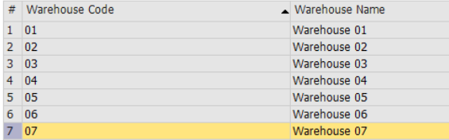

BIN LOCATION
The bin location to be setup as per appendix SAP WAREHOUSE BIN LOCATION file.

If turn on the bin location, there will be an additional tab in the warehouse setup screen:
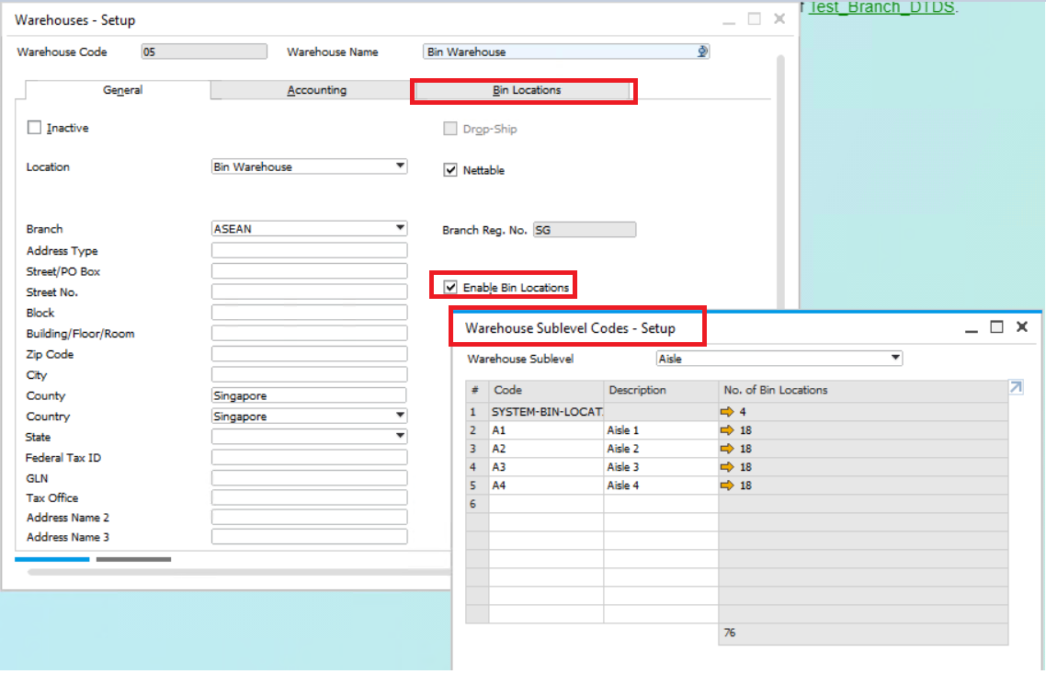

ITEM DIMENSION
Item dimension such as Length, Width, Height, Volume, and Weight will be entered during the creation of item master data.

# | Item Dimension | Unit of Measure
1 | Length | MM, M2
2 | Width | MM, M2
3 | Height | MM, M2
4 | Volume | M3
5 | Weight | Kg

ITEM MASTER DATA
All items that are to be used in transactions or will be taken into stock need to be created in SAP B1 Item Master Data.

It is recommended to have one single personnel in charge of creating new item master data to avoid duplication entry in the future.

SAP B1 allows up to maximum 50 characters for Item Code and up to maximum 200 characters for Item Description.

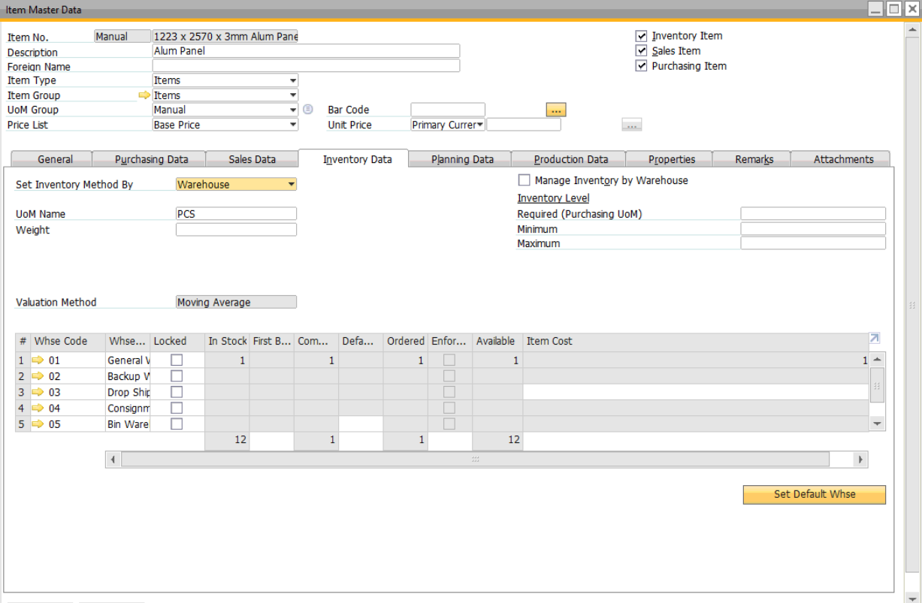

BATCH MANAGEMENT (ONLY FOR COIL ITEM)
It is possible to setup in SAP B1 Item Master that an item is managed by batch.
Batch Number Management method will be ‘On Every Transaction’ which means during receiving and issuing, user needs to indicate the batch number. Example: document such as GRPO, Delivery Order, Pick List, Issue for production requires selection of batch number.

User to enter the following information in the batch number :
- Supplier
- Dimension
- Net Weight
- Grade/Temper
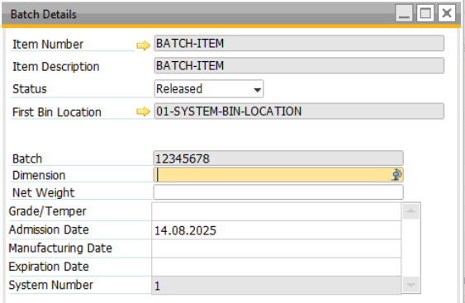

NOTE : Coil’s Finish Product cannot and will notbe set to manage by Batch Number as this will impact the Work Order Queue Customization. To set Coil’s Finish Product to managed by batch – YSM will submit a change request to the work order queue program.

The Batch Number transaction report can be used to view the transactions history include where the item is purchased from, used for which production order etc.
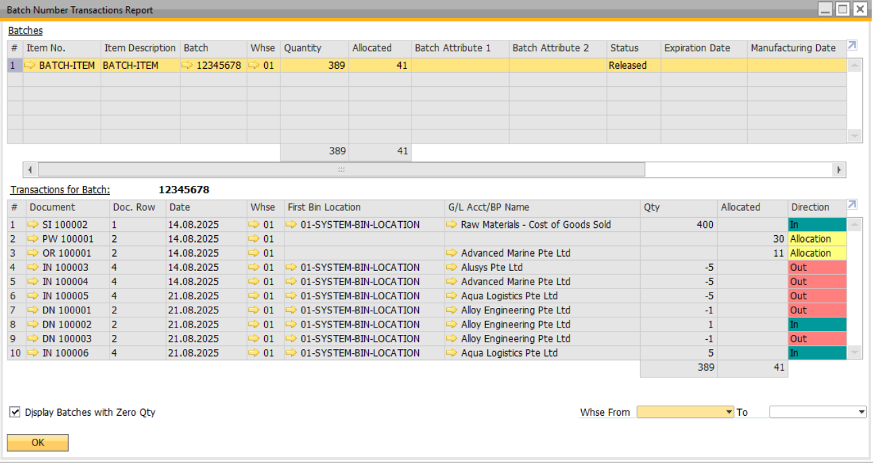

UNIT OF MEASURES
Following are UOM conversion discussed and agreed.

Purchasing conversion:
Extrusion -
PCS to PCS

Coil -
Ton to KG
Plates: KG
purchase in TON keep inventory in Sheets
buy in sheets sell in M2
Density
Thickness (width - Length - Height)

Plates are in Length & sheets but if cut from coil, coil usage is deducted in Kgs

BP CATALOG NUMBERS (CUSTOMER PART NO)
User can configure SAP Business One to use customer and vendor catalog numbers in parallel to item numbers. This means that user can use the item number of the vendor in the purchase order, and the item number of the customer in the sales order.

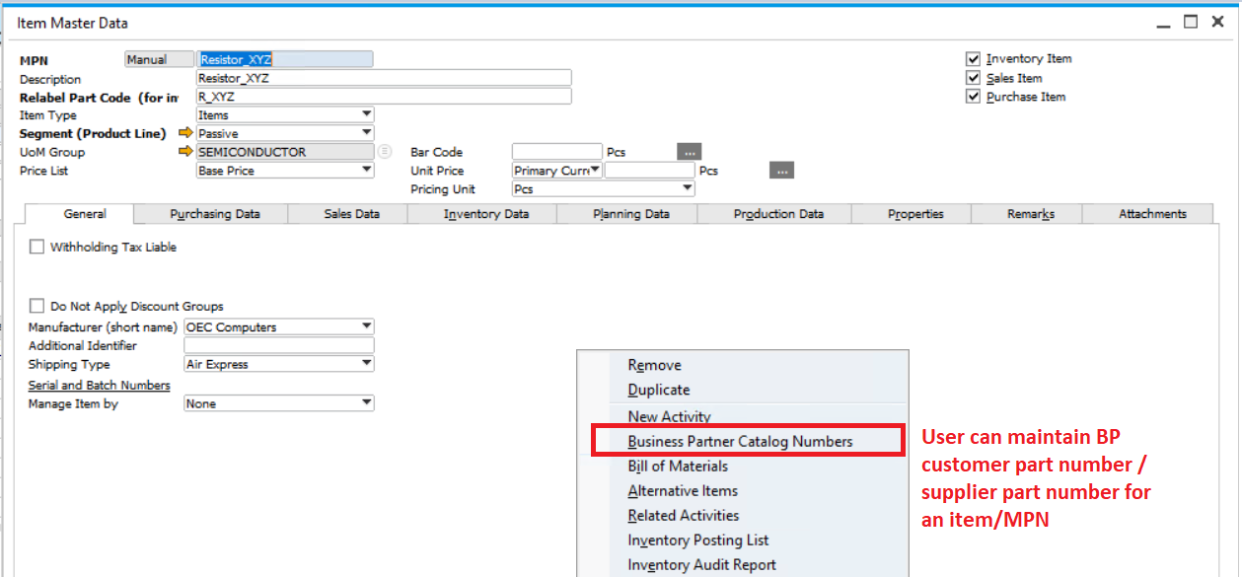

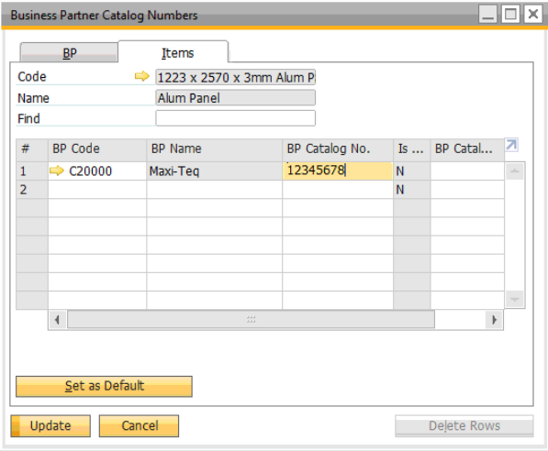

LEAD TIME
Lead time will be maintained in the item master.

In SAP B1, lead time is used for MRP purpose. The measurement is in days.

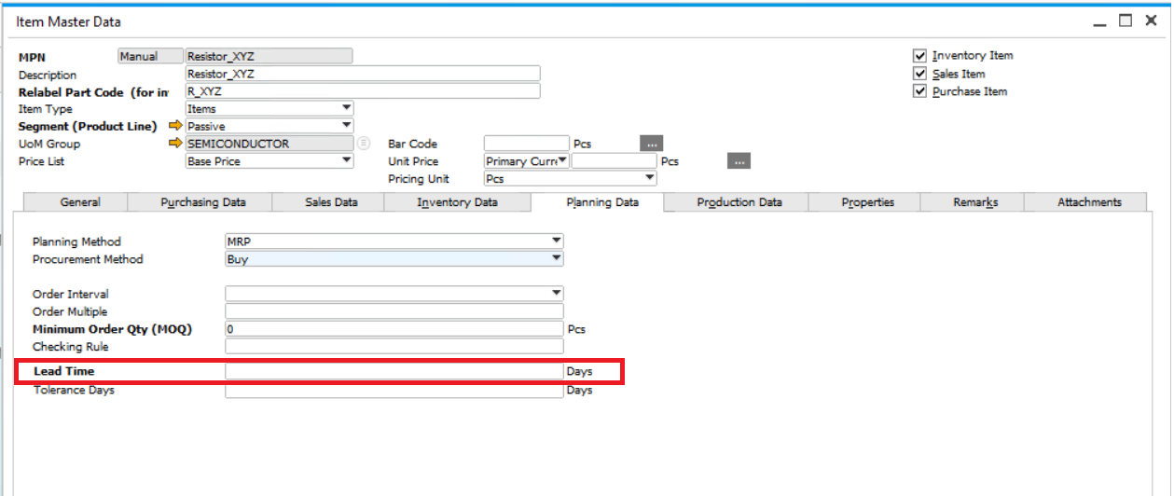

MINIMUM ORDER QUANTITY (MOQ)
Minimum Order Quantity will be set up in item master data.
In SAP B1, Minimum Order Quantity is used for MRP purpose.

MINIMUM AND MAXIMUM INVENTORY LEVEL
In SAP B1, user will set up minimum and maximum inventory level for items.

Since inventory is managed by warehouse, minimum inventory level has to be set at warehouse level.

PRICE LISTS
In SAP B1, price list can be maintained and it is possible assign to one price list to a business partner in business partner master.

STANDARD PRICE LIST
During the creation of sales and purchasing documents, SAP Business One derives item prices directly from a price list that is linked to a business partner. This price list can be linked by default from the business partner's group or from the business partner's payment terms, or can be selected manually in the business partner master data. When user adds a business transaction for a business partner, the price of the item is determined by the assigned price list.

SAP Business One provides 10 default price lists. User can use from any to all 10 of them. User can define new price lists and delete existing ones. User can also link different price lists to one another using multiplication factors. In each price list user can define up to three prices with different currencies for each item. In addition, user can set different prices for each of the item's units of measurement (UoM). Maintaining different price lists for items makes it possible to set special prices and quantity-dependent discounts in each one, thereby letting user offer customers customized prices.

DISCOUNT GROUPS
User can define more general discounts, that is, discount groups. User can define four different types of discount groups as follows:

- For all Business Partners
- For a specific customer group
- For a specific vendor group
- For a specific business partner

In each of the above discount groups' types, user can define any of the following discount groups:

- Item group discount
- A combination of item properties discount
- Item manufacturer discount
- Item specific discount

This discount is applied to the price list specified for the business partner in the master record.

Multiple discounts can be defined in any discount groups. For example, if user has defined a discount group for Item groups, user can define in the same discount groups also discounts for manufacturers.

SPECIAL PRICES FOR BUSINESS PARTNERS
Item prices are usually defined in various price lists. The price list that is relevant for determining the prices for a particular business partner is specified in the master data record of that business partner. A general discount can also be specified for the business partner in the master data record. This discount is applied to the total of the item prices in the document.

However, it is often necessary to define special prices for individual cases. For example, user may require special prices for an item or an item from an item group for a particular customer or vendor. User may also want to specify special prices or scaled discounts for a particular customer that will be selected automatically by the system on the basis of the quantity ordered.

INVENTORY REVALUATION
If there is requirement to amend item cost / write down the value for existing items in warehouse, it will be done using Inventory Revaluation in SAP B1. Only authorized users can create Inventory Revaluation.

System only allows users with professional license to create the inventory revaluation in SAP B1.
As discussed, inventory revaluation will be done at year-end to write-down slow-moving or not moving items. SAP B1 will do revaluation based on item code, not by batches.
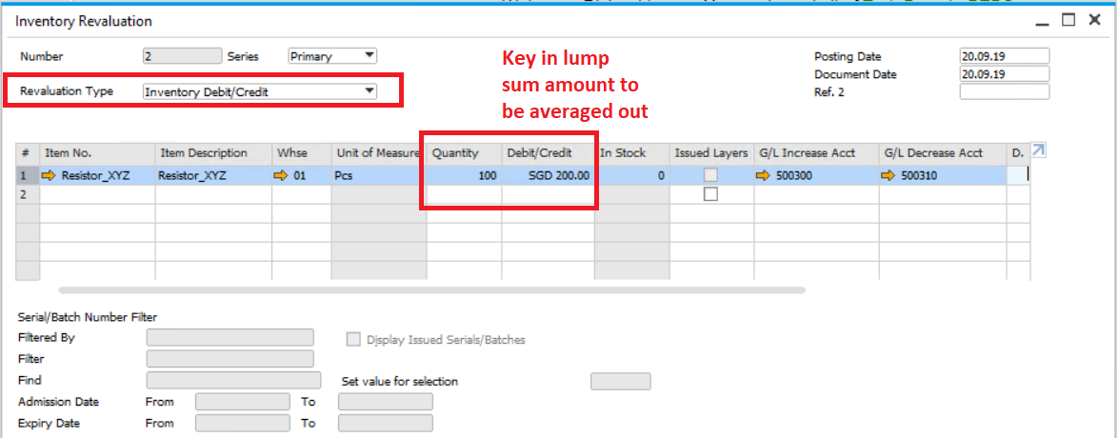

INVENTORY TRANSFER REQUEST
Inventory transfer request will be used to request for item transfer from one warehouse to another warehouse. There will be no inventory impact for this document.

In the inventory transfer request document, user will enter item code, quantity, from warehouse and to warehouse.

INVENTORY TRANSFER
Inventory transfer allows user to transfer inventory from a location to another location, for example from main warehouse to reject warehouse.

In the inventory transfer document, user will enter item code, quantity, from warehouse and to warehouse.

The journal entry for Inventory Transfer:
DR Inventory Account
CR Inventory Account

GOODS RECEIPT AND GOODS ISSUE
Inventory goods receipt and goods issue in SAP B1 can be used for receipts or issue which is not related to purchase or sales transaction.

Goods Receipt is used for:
- Stock Adjustment In

Goods Issue is used for:
- Stock Adjustment Out
- Write off

Inventory quantity and value will be adjusted accordingly and JE will be posted. The JE for Goods Receipt will be:
DR Inventory Account
CR Inventory Offset Account

The JE for the Goods Issue will be:
DR Inventory Offset Account
CR Inventory Account

INVENTORY COUNTING
SAP B1 has standard stock take function which involves three steps:
- Print Stock Count sheet
- Update Stock Count into the system
- Post the Final Stock and its variance

When the items are in the counting process, stock related transactions should not proceed. For example: Delivery Order, Goods Receipt, etc., should not be posted.

User will practice stock count in quarterly basis. Stock count sheet can be generated from system.

User will then update the counted quantity into the system. Finally, the variance will be posted accordingly.

REPORTS
SAP B1 has standard inventory report as below:

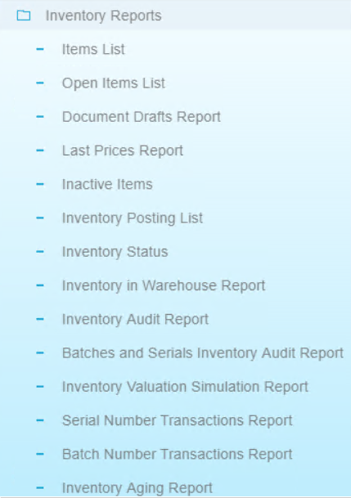

PRODUCTION
Yan San Metal will use SAP B1 standard Production module for Fabrication and cutting products.

PROPOSED WORKFLOW IN SAP B1

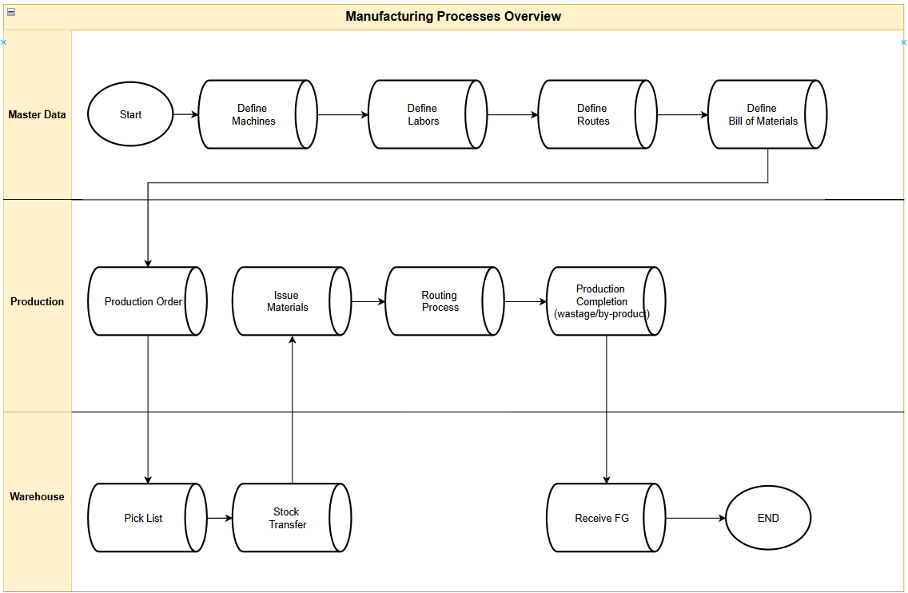

RESOURCES MASTER DATA
In SAP Business One, resource master data is used to define and manage resources like machines and labor that are essential for production processes. It allows users to specify resource types, groups, units of measure, and capacity information, which are then linked to production orders. This enables efficient planning, scheduling, and cost calculation for production runs.

In Yan San, resources will be used to register machines and or labour to be used in production processes such as Cutting, Hole Drilling machines etc.

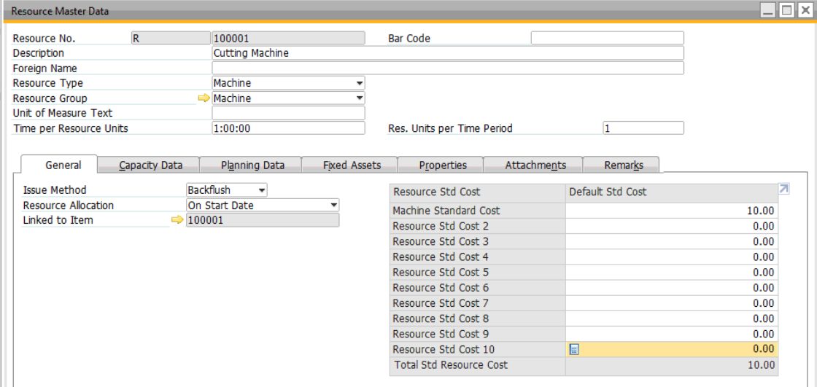

PRODUCTION ROUTING
In SAP Business One, production routing defines the sequence of operations and resource allocation for manufacturing a product. It breaks down the production process into distinct stages, allowing for a more structured and efficient manufacturing process. This enables better control over material and resource allocation, scheduling, and tracking of production progress.

In Yan San, production routing will be defined for production processes such as:
- Cutting
- Hole Drilling
- Bending
- Welding and etc
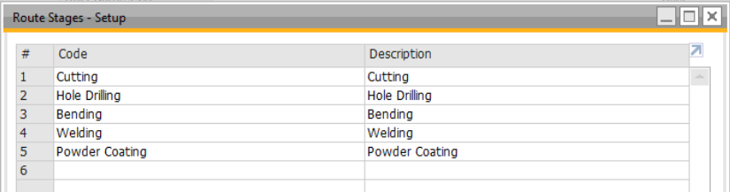

Additional routing process can be defined as needed.

BILL OF MATERIALS
Bill of materials (BOM) will be setup in SAP B1.

Both the components item codes and finished product item codes have to exist in the item master in SAP B1 before used to create BOM.

Before starting the production process, user needs to ensure the BOM code has been created in SAP B1 otherwise the standard production order could not be generated.

The quantity for cutting components will be calculated as such:

The BOM in SAP Business One as below:
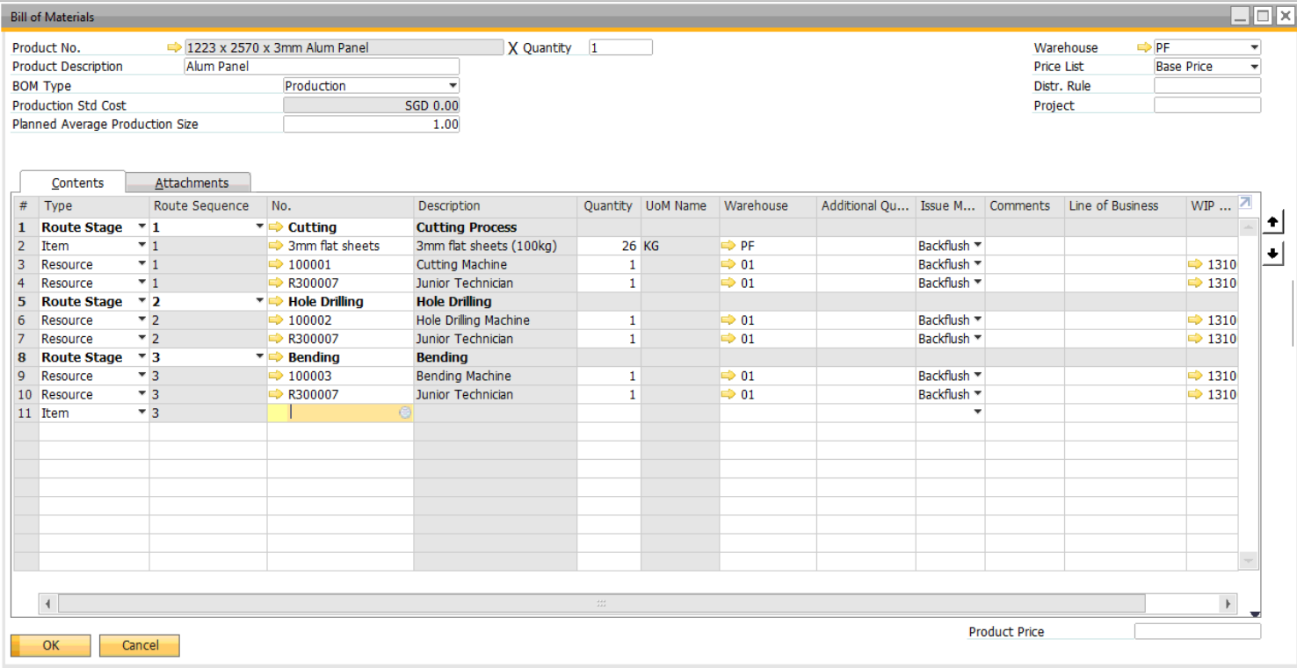

PRODUCTION ORDER
In SAP B1, Production Order (work order) will be used for any additional process done to finished goods hence the cost of components and labors will be incorporated inside.

In Yan San, work orders for cutting can be created from Sales Order.

Production in SAP Business One as below:
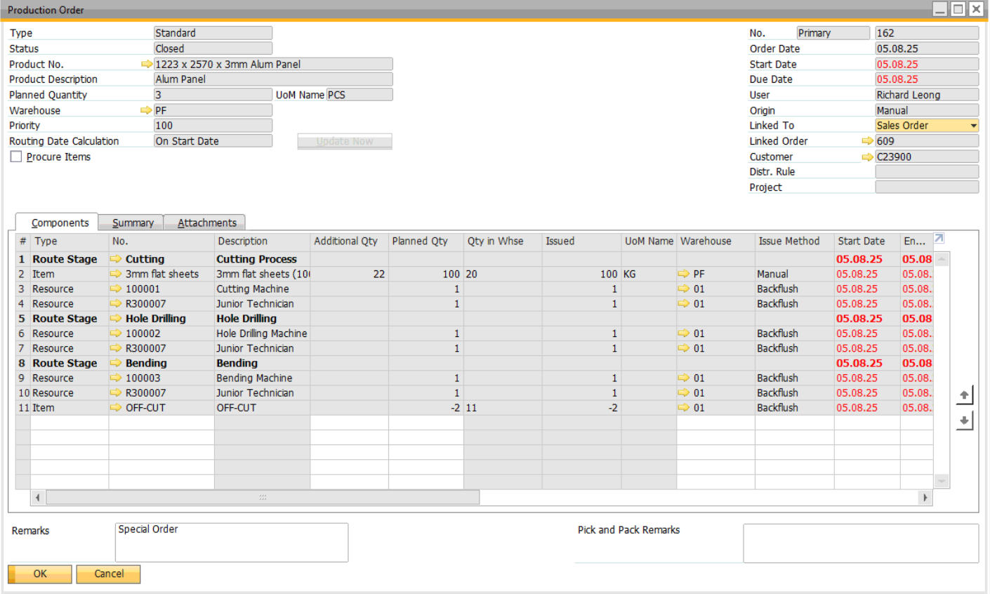

WORK ORDER PRINTOUT

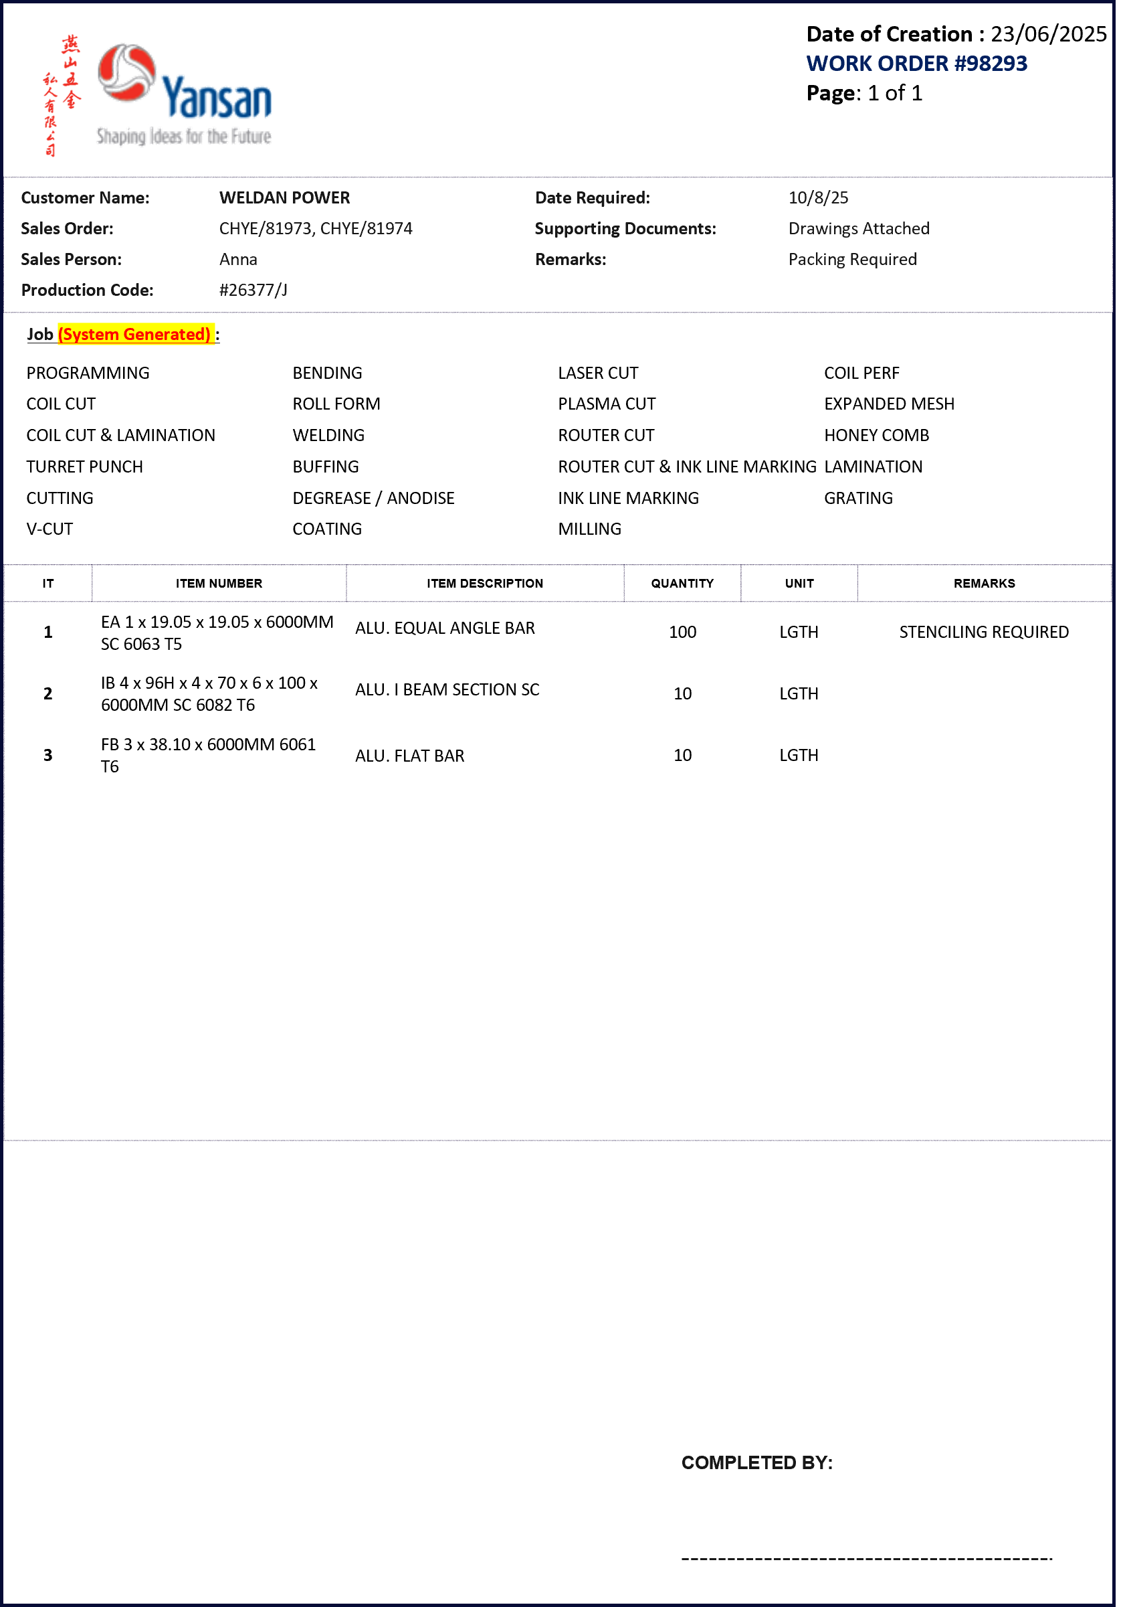

PRODUCTION ISSUE

When the component items had been picked and available, user will perform issue for production to consume component used for production.
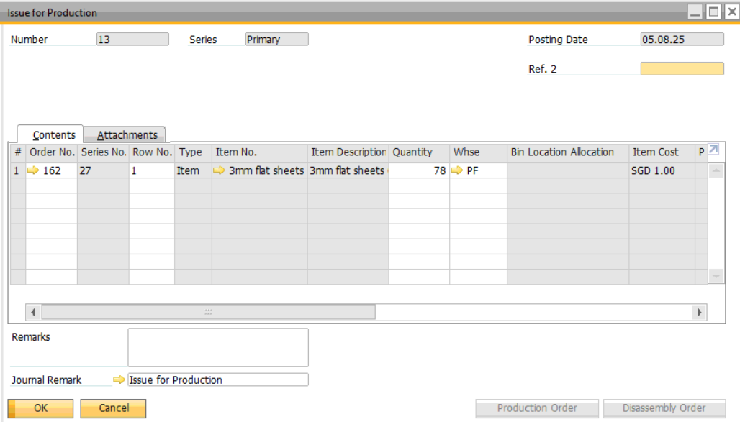

PRODUCTION RECEIPT
In SAP Business One, a receipt from production is the process of recording the completion of a production order and updating inventory with the finished goods.

In Yan San, the receipt from production can be done via customization screen named “Work Order Queue”. Refer to appendix for the detail functionalities.

Alert to send to Sales team upon production receipt with the following information:
No | CPO No |  | SO  No | Customer | Work Order # | Item No | Description | Planned Qty | Completed Qty | Outstanding Qty
6 | 82999 |  | 1234 | HSL Constructor | 6 | 1397mmx2570mmx3mm | Alum Panel | 1pc | 1pc | 0
7 | 82999 |  | 1234 | HSL Constructor | 7 | 1400mmx2570mmx3mm | Alum Panel | 1pc | 1pc | 0
8 | 82999 |  | 1234 | HSL Constructor | 8 | 1422mmx2570mmx3mm | Alum Panel | 2pc | 2pc | 0
9 | 82999 |  | 1234 | HSL Constructor | 9 | 1430mmx2570mmx3mm | Alum Panel | 1pc | 1pc | 0

OFF-CUT & RETURN COMPONENT
The term OFF-CUT is referring to receiving back a remainder of “Raw-Material” back to inventory as a “DIFFERENT” item, while Return Component is receiving back a remainder of “Raw Material” back to inventory as a “SAME” item.

In SAP B1, the OFF-CUT item will be included in one of the production order as an example below:
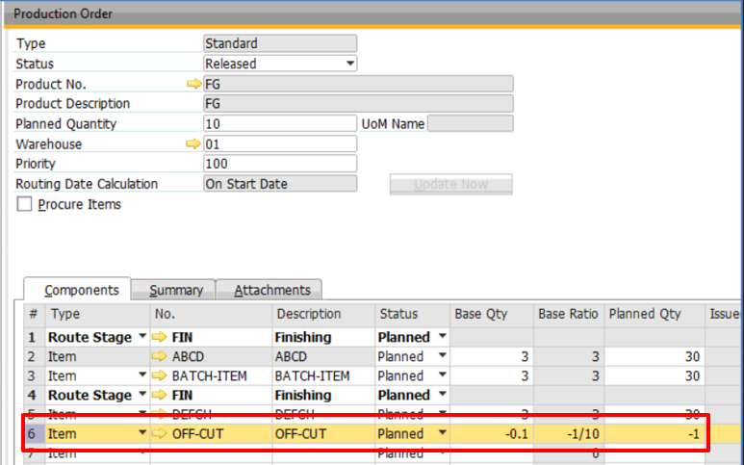

The off-cut can be received with or without cost.
Receiving off-cut with cost will result in the cost of the off-cut reducing the finish product cost, while without cost will result in the FG absorbing all the material cost.

The Return Component as example below:
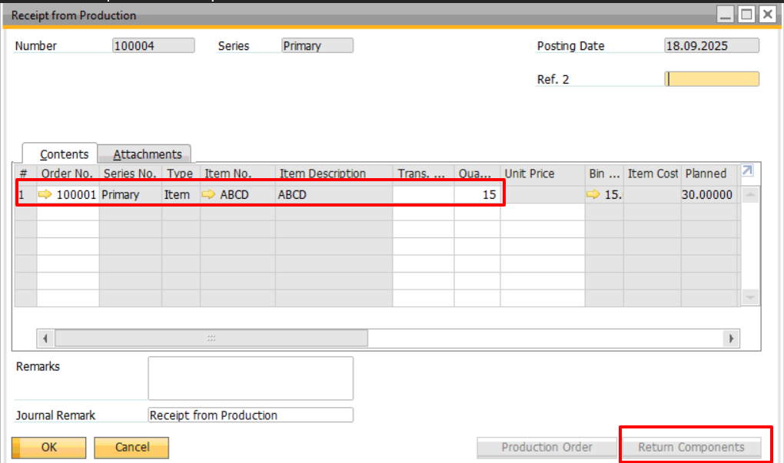

The off-cut handling too had been included in the “Work Order Queue” customization program, this is so to streamline the process of registering and receiving off-cut.

MRP

FORECAST
Different forecasts can be setup. Weekly, daily and monthly forecast can be setup.

During MRP run, only 1 forecast can be selected.

Sample of monthly forecast in SAP Business One:
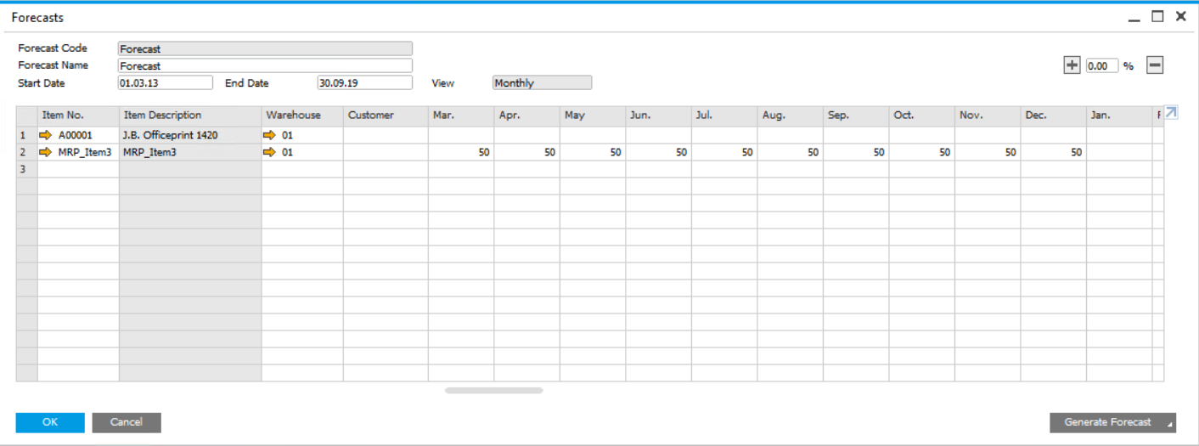

MRP
The Material Requirements Planning (MRP) module enables user to plan material requirements for a manufacturing or procurement process based on the re-evaluation of existing inventories, demands, and supplies on changing planning parameters (such as lead time determination, make or buy decisions, and holiday planning).

MRP calculates gross requirements for the highest bill of materials (BOM) level, based on existing inventory, sales orders, purchase orders, production orders, forecasts, and so on. It calculates gross requirements at the lowest BOM levels by carrying down net parent demands through the BOM structure. Dependent levels might have their own requirements, based on sales orders and forecasts.

The results of the MRP run are report and recommendations that fulfill gross requirements by taking into consideration the existing inventory levels and existing purchase orders and production orders. The MRP run also takes into account predefined planning rules such as Order Multiple, Order Interval, Minimum Order Quantity, Inventory Level, and so on.

ORDER RECOMMENDATION
MRP will give order recommendation where user can decide whether to create documents based on the recommendation or purely for recommendation.

HUMAN RESOURCES
This module will be used for setup employees’ data and owner (preparer) of the document.

All the users using SAP B1 must be created in here. The SAP User ID is also assigned to the Employee.

EMPLOYEE MASTER DATA
The employee’s name is entered as:
- First Name (Christian name or given name)
- Last Name (surname or family name)

The Employee No is auto-assigned to employee. It can be ignored.
User needs to attach the SAP User Code to the Employee.

Every time the document created under the SAP User Code, the preparer or the document owner will be recorded as the employee name.

APPENDIX

WORK ORDER QUEUE

SAP WAREHOUSE BIN LOCATION

